**Skills Demonstration 1**

**Graphical User Interface Programming**

**Weighting: 30%**

**Code: 6N0736**

**Date: 10/02/2020**

**Computer Science 2019-2020**

**Tutor: Deirdre Shaw**

Contents

Test Plan 3

Form 1 Test 3

Test 1: 3

Test 2: 4

Word Processor Test 5

Test 2: 6

Web Browser Test 7

Test 1: 7

Test 2: 9

Picture Viewer Test 10

Test2: 12

Calculator Test 13

Test 1: 13

Test 2: 15

Drag and Drop Test 16

Test 1: 16

Test 2: 18

End User Guide 20

Main Form 21

About Form 21

Word Processor Form 22

Calculator Form 23

Picture Viewer Form 23

Drag and Drop Form 25

Web Browser Form 25

# Test Plan

This is for the Test plan to show different types of workings for the program required for this assignment. We will do 2 tests per form and then we will analyse each test for maximum performance.

## Form 1 Test

Test 1:   
Background Colour change for user.  
To access the colour change you would go to the main form and access the Edit drop down from the top. It would then allow for you to change to one of the set colours, we shall test Yellow.

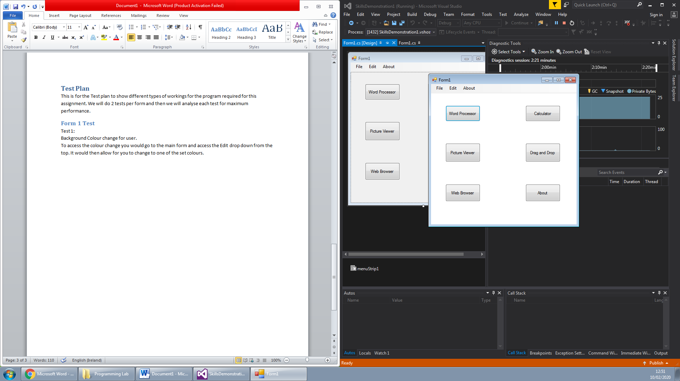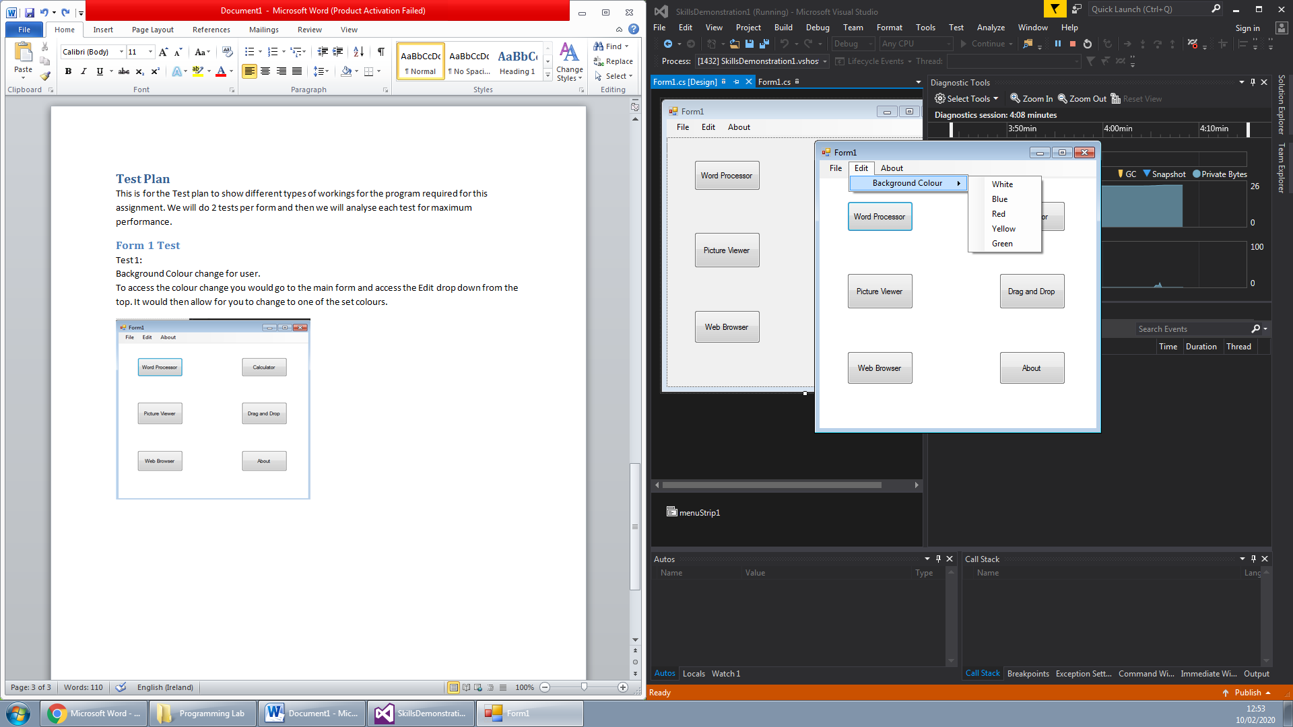

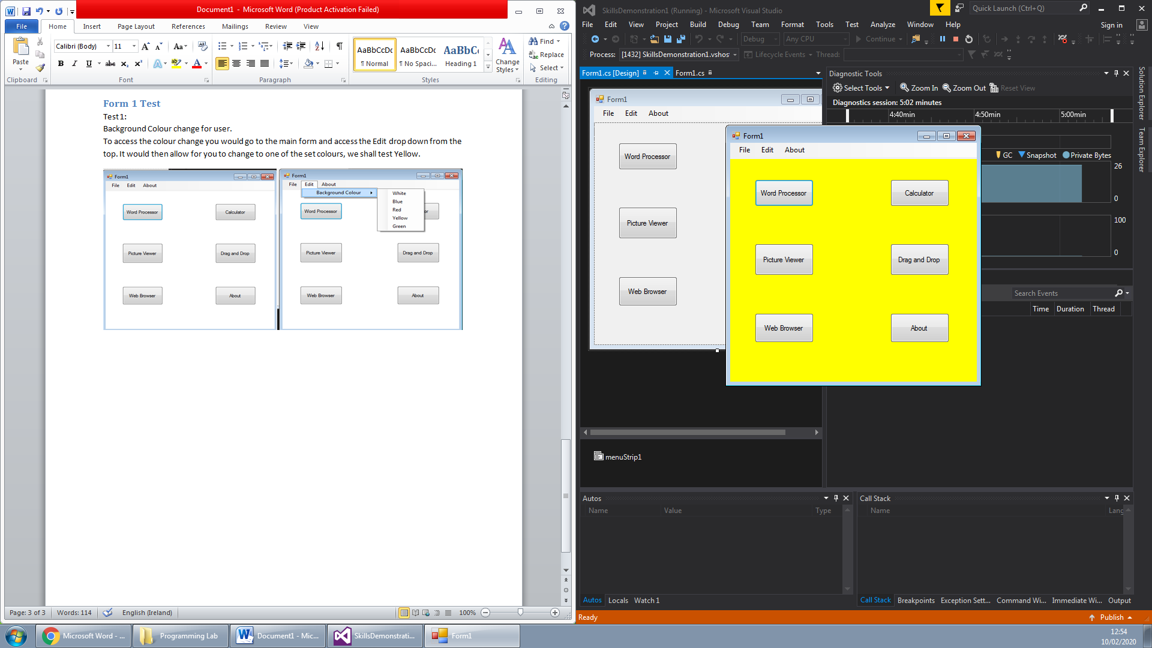

After testing that each check had worked we signed off on it as an approved piece of work.

Test 2:  
Access to other forms through menu drop down.  
We tested to see if the access to other Forms for the program were accessible through the drop down. We tested each one to see how it worked.

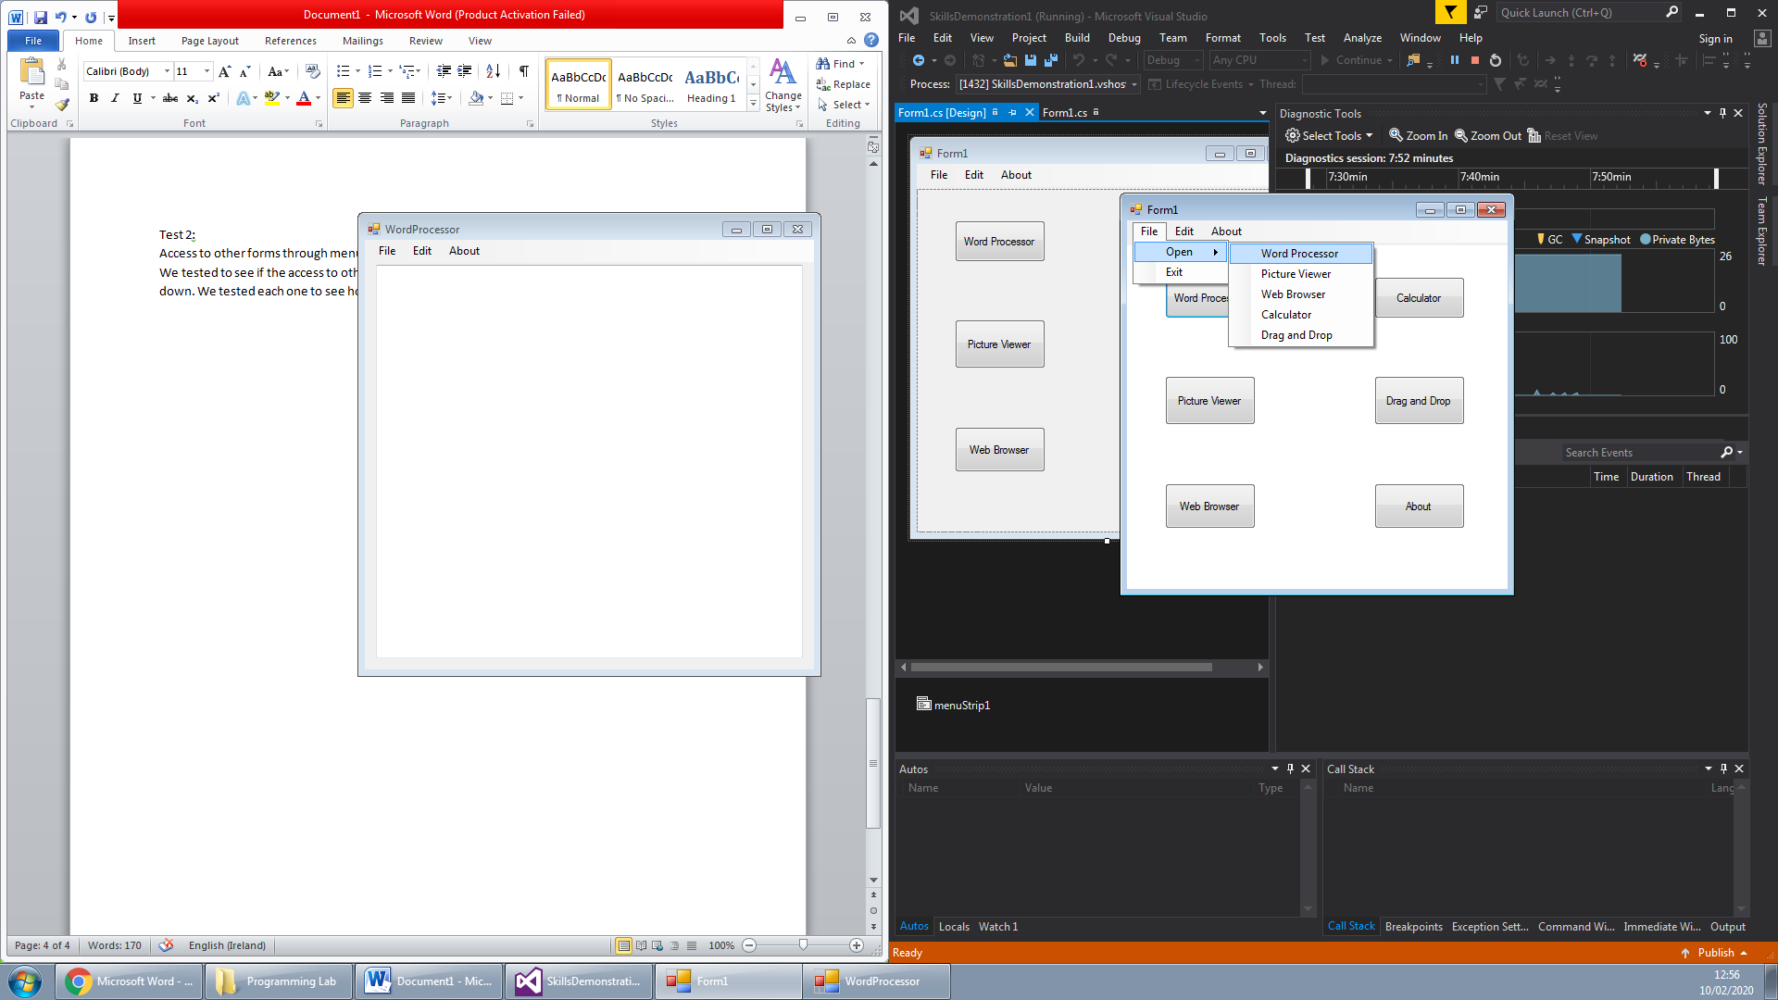

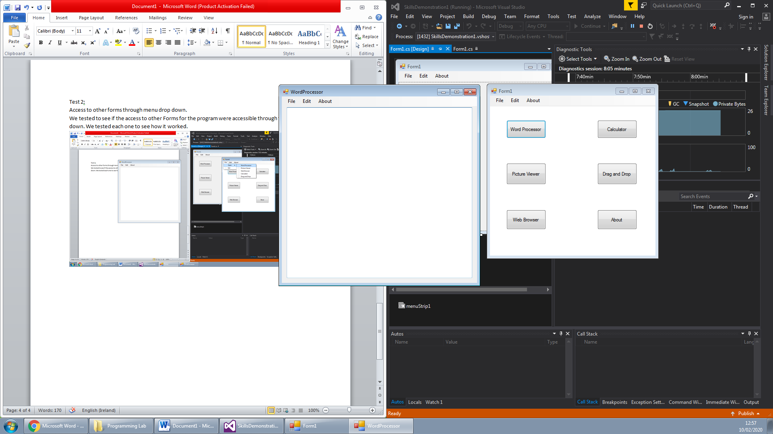

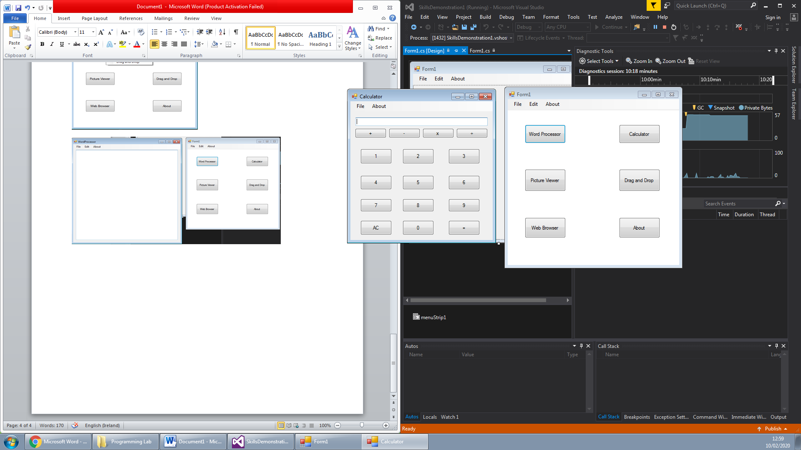   
Based from this we declared that it worked and we approved of this test as a working positive.

## Word Processor Test

Here we will do the testing for the word processor application. The first test we will do will be:  
Test 1:  
To see if the changing of font and font colour works.

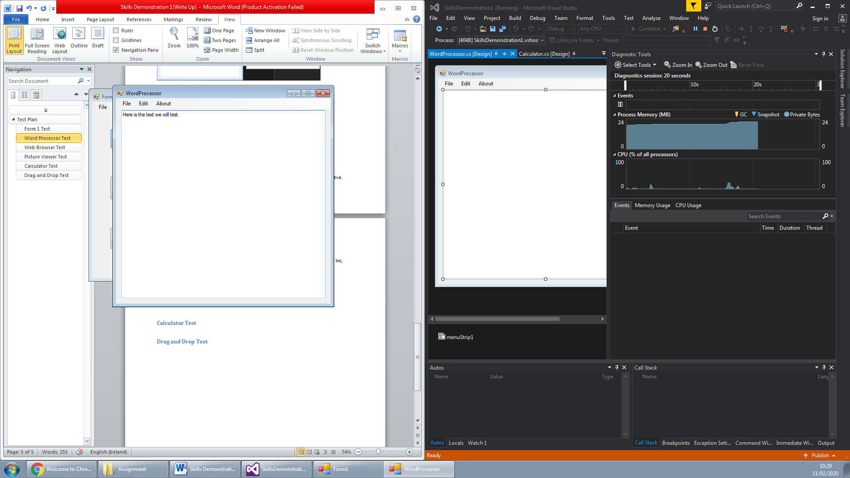

First we set the font size to the smallest and set the colour to black. Now we will apply changes.

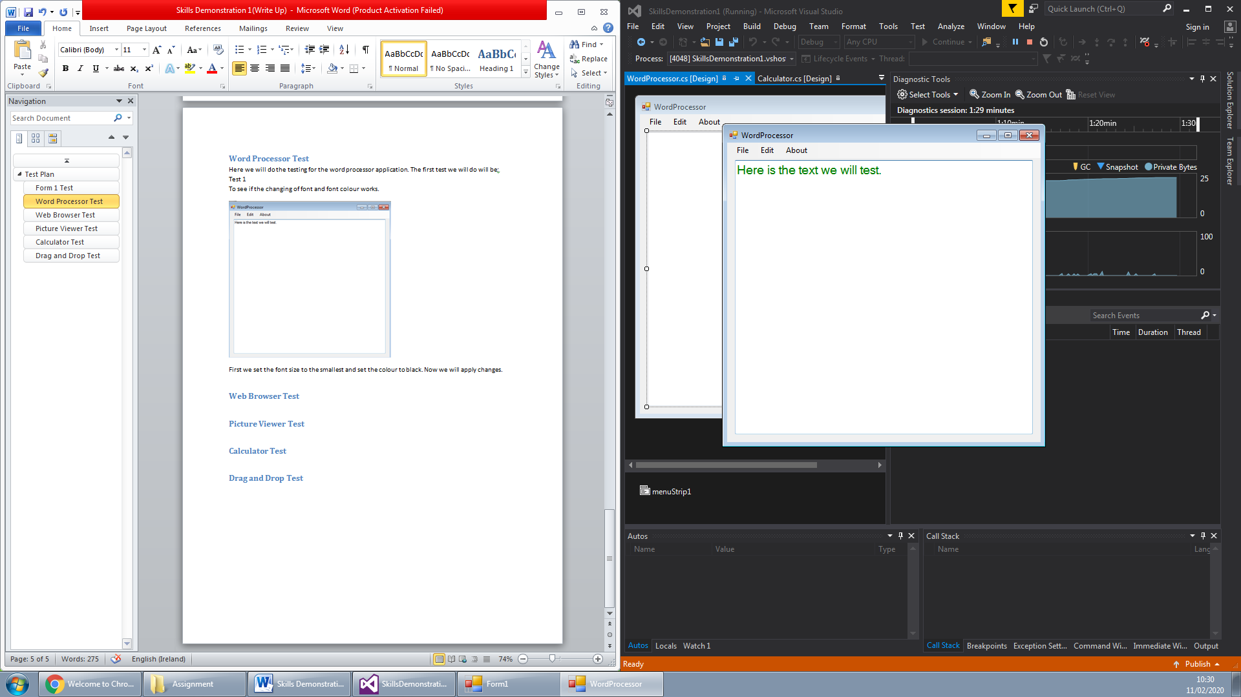

Based from the image shown above it has shown that the first test was a success and the text size changed as well as the colour. This has received approval of pass.

Test 2:  
To see the change of font type as well as change of background colour.



We will use the previous image from the last test as a base for our test. We will now proceed to change the font type and the background colour.

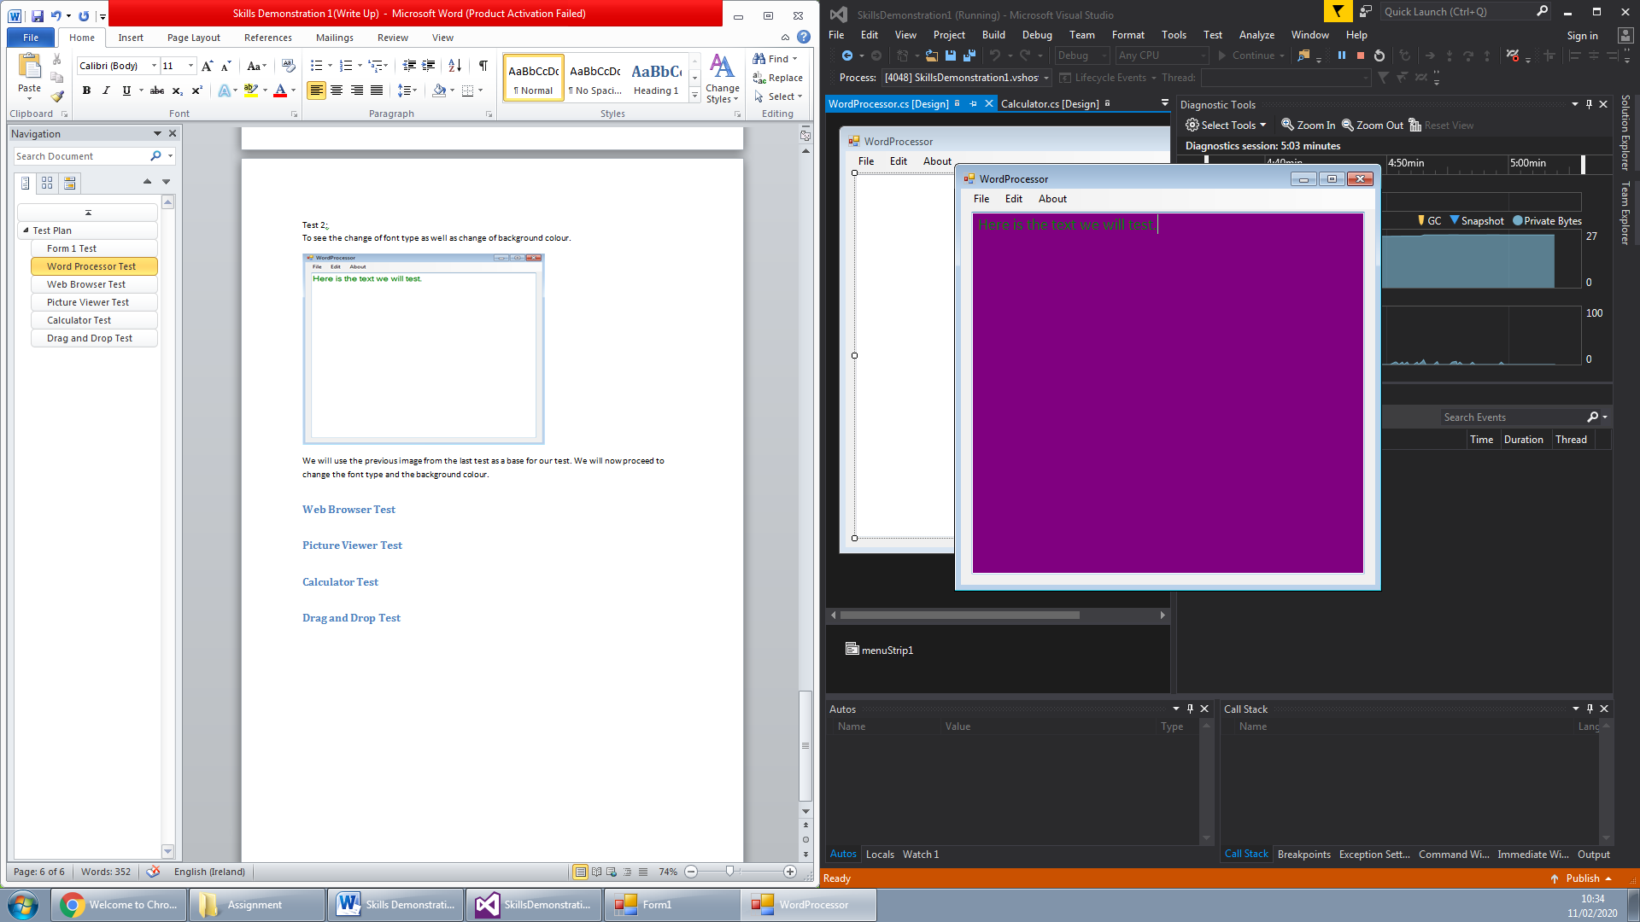

As it can be seen from the image above the text font has changed and also the background has changed. This is considered a pass for the test as it has done what was intended to do.

## Web Browser Test

Here we will test the Web browser and the different functions in which it can do to observe to see if it works. With our first test we will be testing:

Test 1:  
To test if the Web browser can access different sites using the search URL via text box.  
First part of this test we are going to go to the web browser and put in a URL link into the search bar.

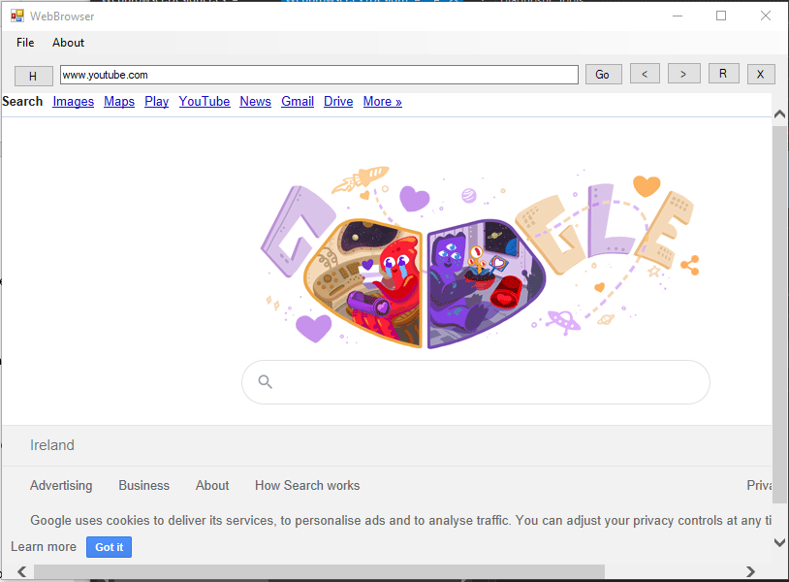  
Once we hit go it changed the page to the expected result.  
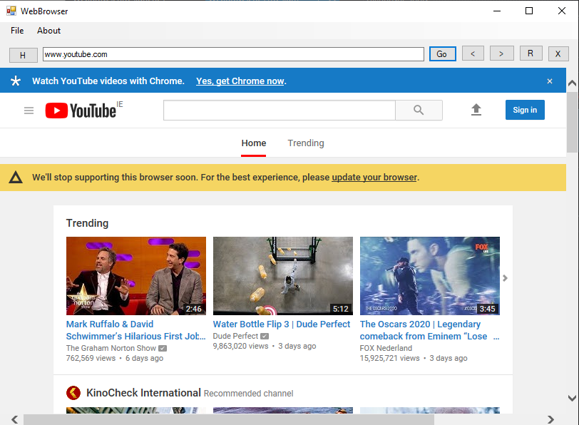

Test 2:  
Testing to see if the control keys in the web browser works as intended (aka. Refresh, go back, go forward, and stop).

First we will try go back.

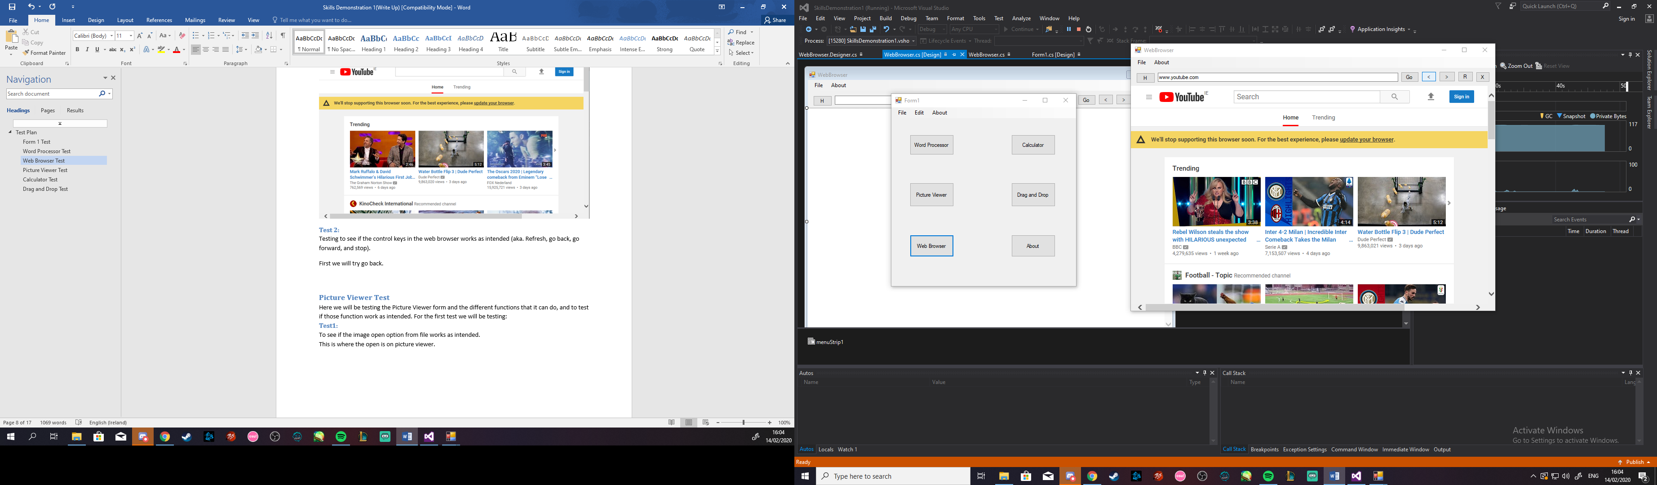

As expected it went to the previous screen that had been loaded.  
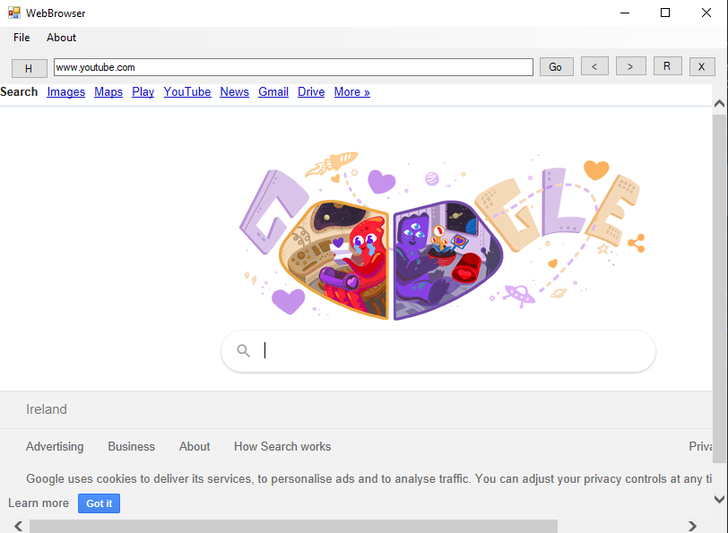  
Next we will try the go forward. So we are expecting to go back to youtube on the browser.  
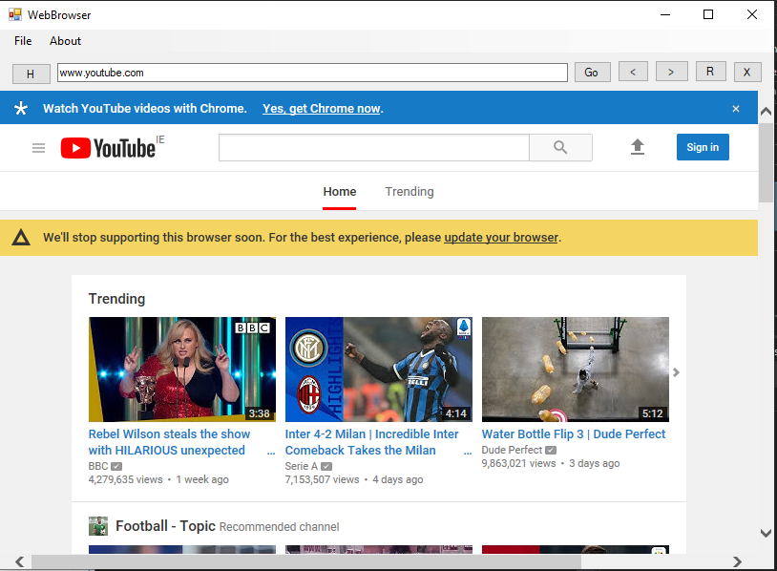  
And as expected it gave us the results that we wanted. This would conclude testing on web browser as a success.

## Picture Viewer Test

Here we will be testing the Picture Viewer form and the different functions that it can do, and to test if those function work as intended. For the first test we will be testing:  
Test1:  
To see if the image open option from file works as intended.  
This is where the open is on picture viewer.

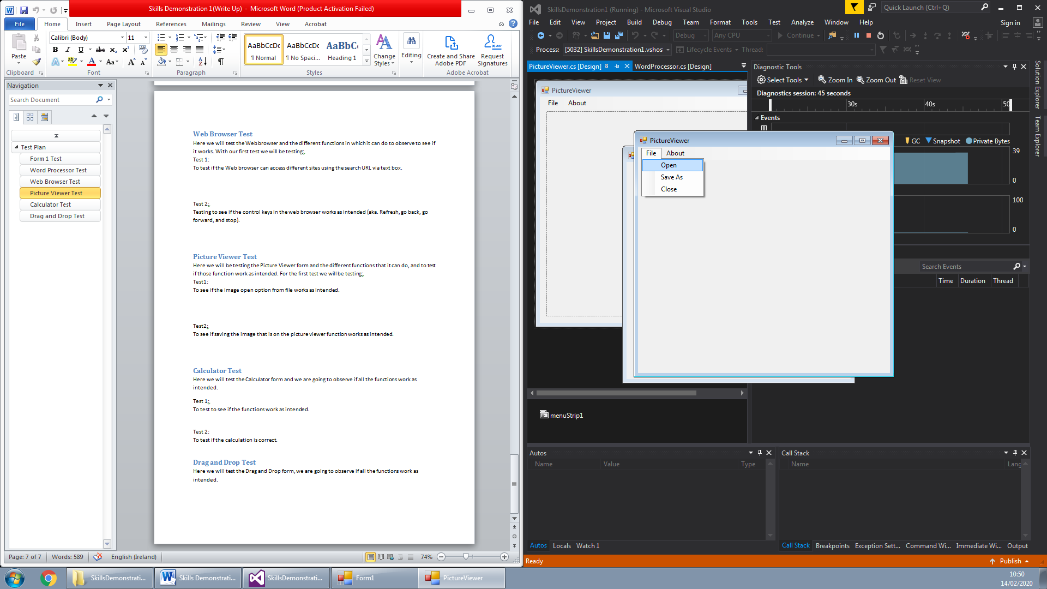

This is the pop up that is shown once you click open.

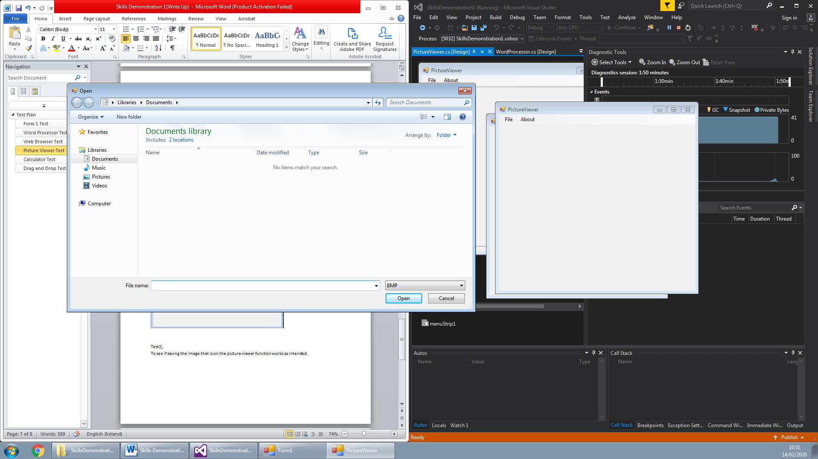

Once selected the image should open on the picture viewr

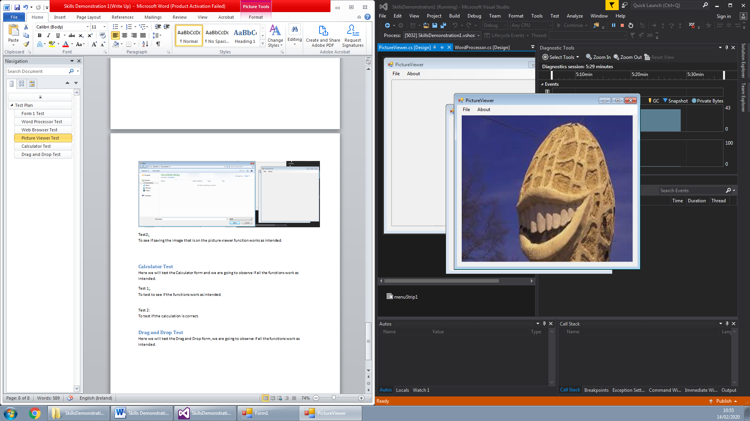

With the image showing itself on the picture viewer it can be concluded that this test was a success.

Test2:   
To see if saving the image that is on the picture viewer function works as intended.  
First we would need to have an image in the picture viewer. We would then go to where the image points to,

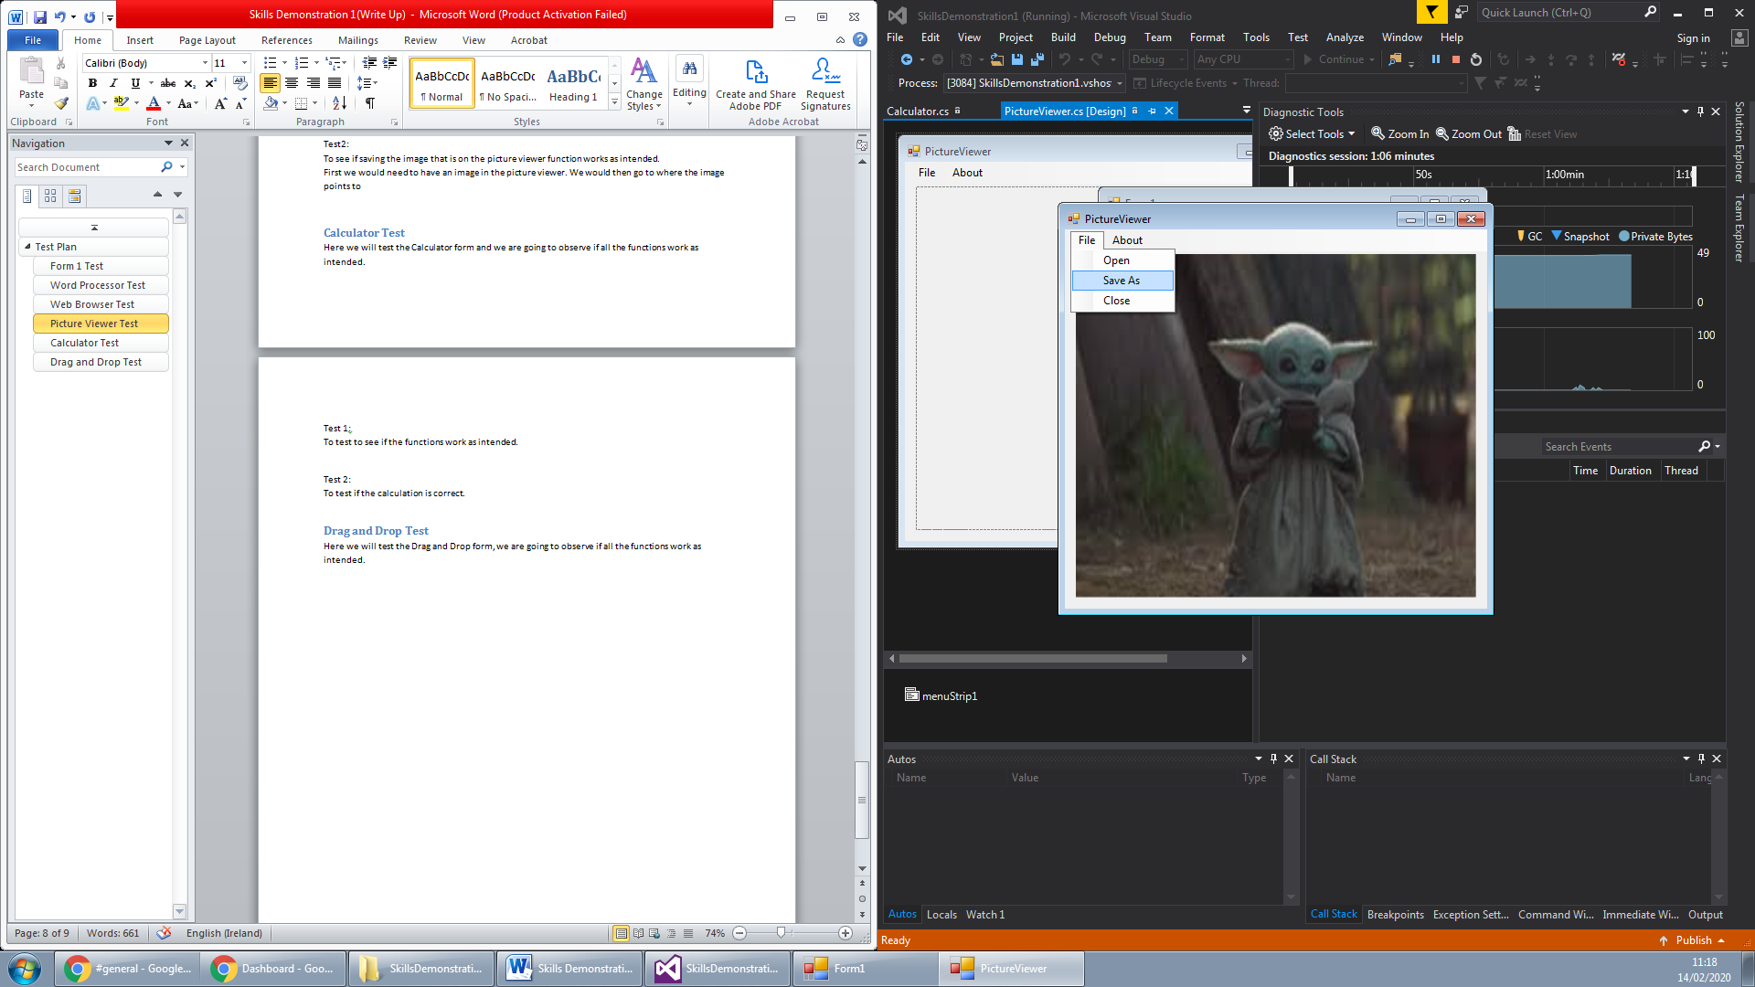

Then with the pop up that comes up you will select the folder that u wish to save the image to.

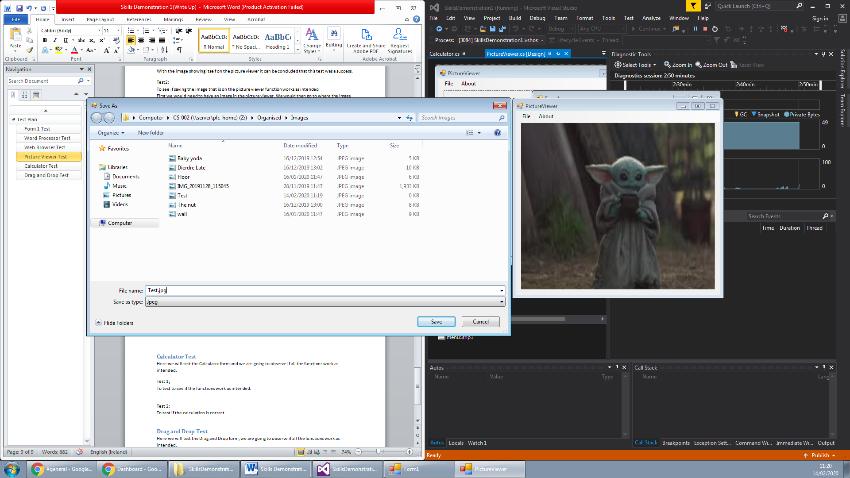  
After that go back to the folder where you saved the image.

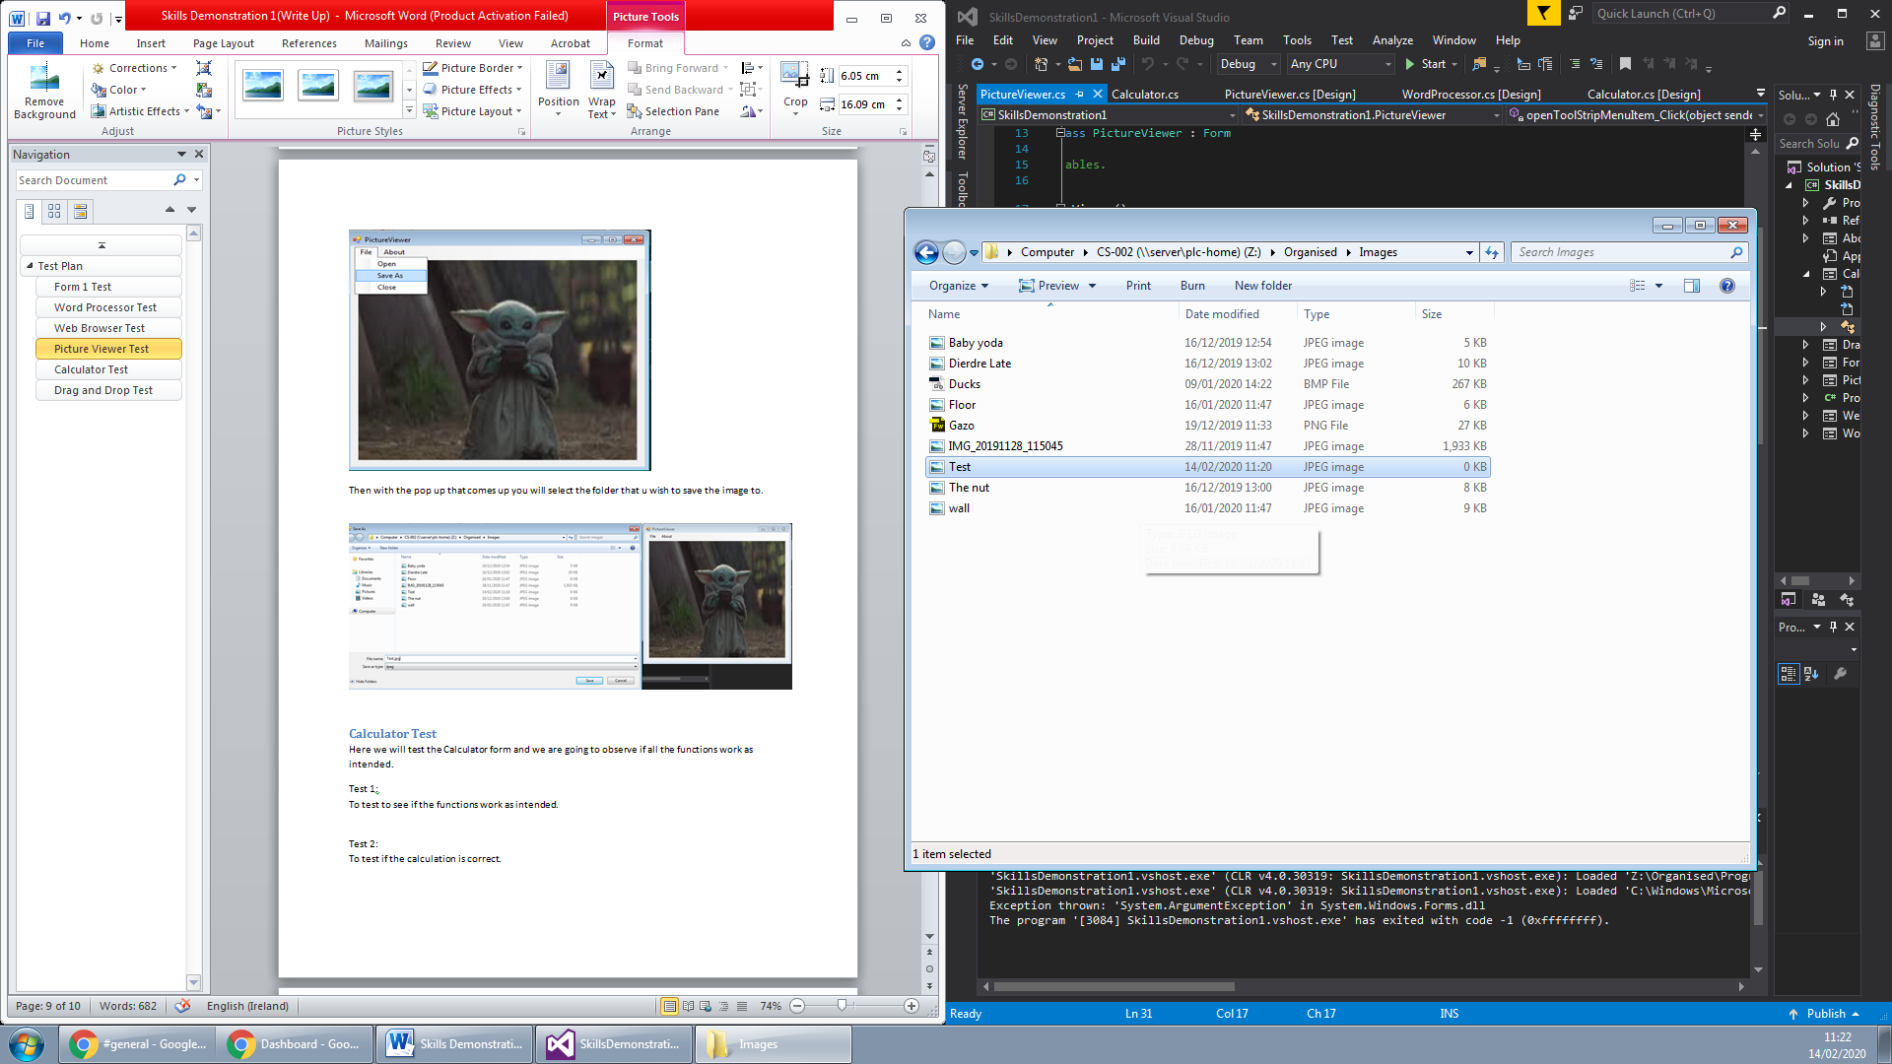

This shows that the file was saved and that the test was successful.

## Calculator Test

Here we will test the Calculator form and we are going to observe if all the functions work as intended.

Test 1:  
To test to see if the functions work as intended.  
Here we will test to see if we can do simple addition on the calculator. First we will input our values on the calculator.

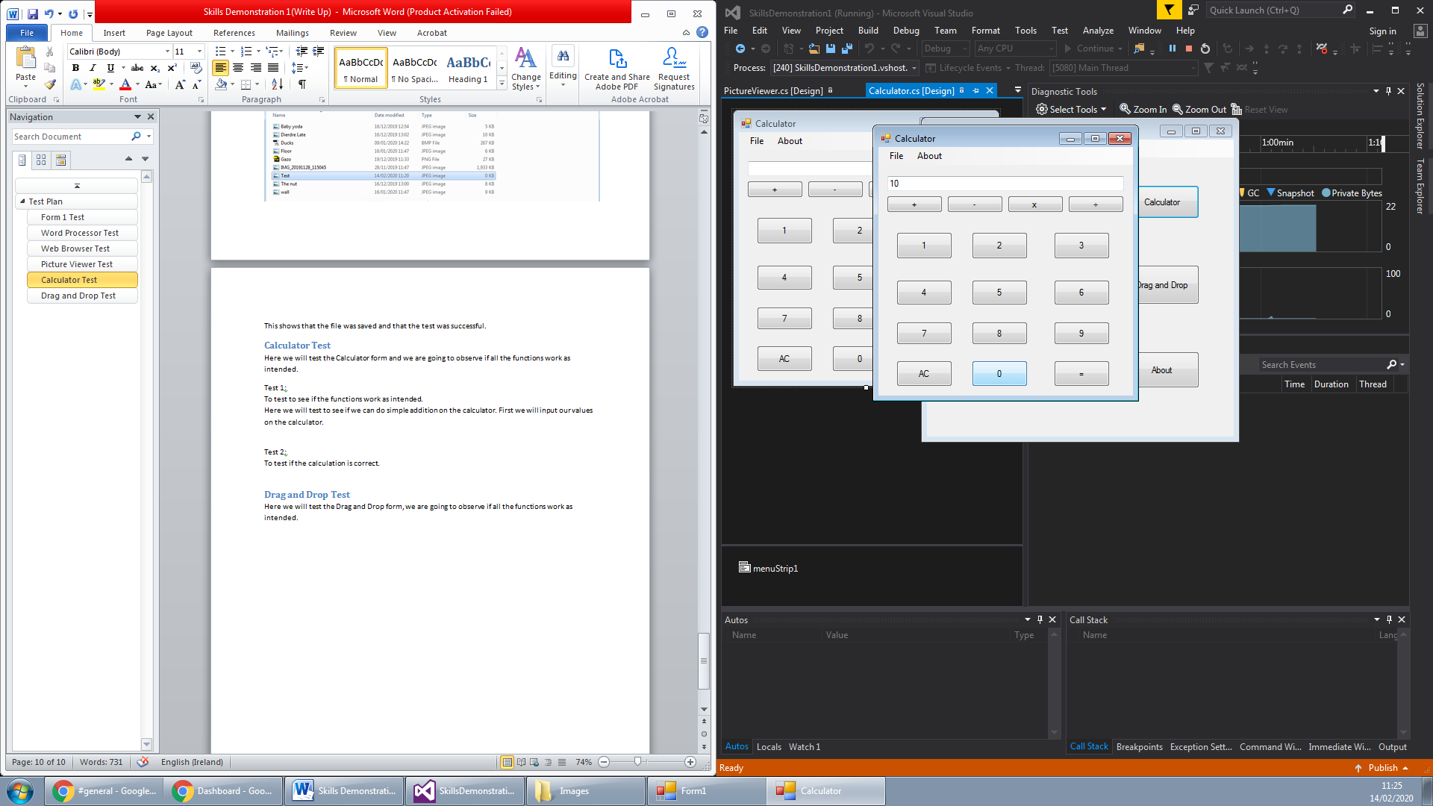  
Now we will put in our addition symbol and then input our second value.

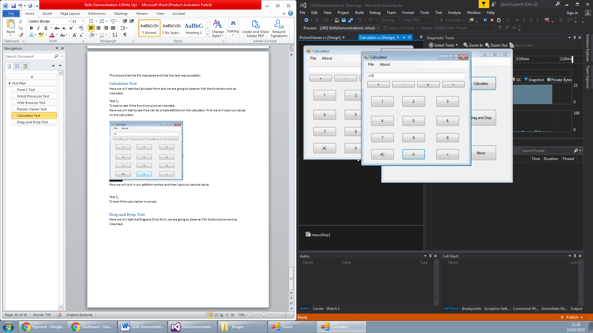  
Next is to receive our answer which should be 20 considering it is 10 + 10.

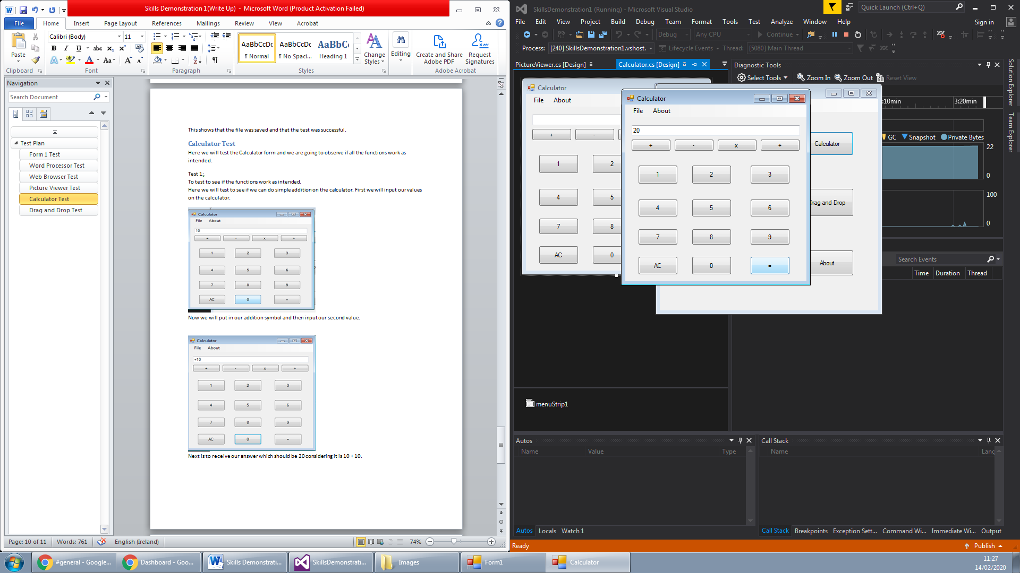

Based from this we know that addition works so we can conclude that this test is a success.

Test 2:  
To test if the calculation is correct.  
In this test we are going to input numbers to test if the calculation is correct.  
We will be doing 3967 + 6535, according to my calculations the answer should be = 10502

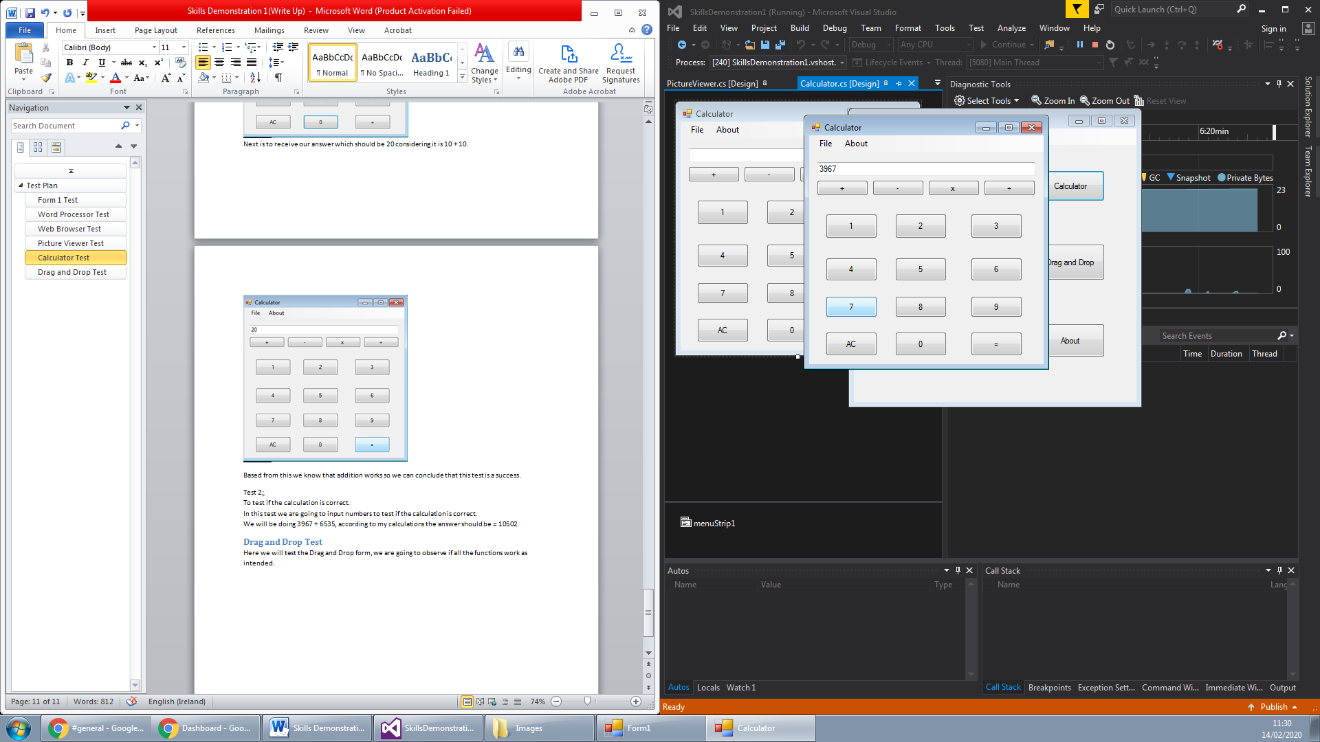

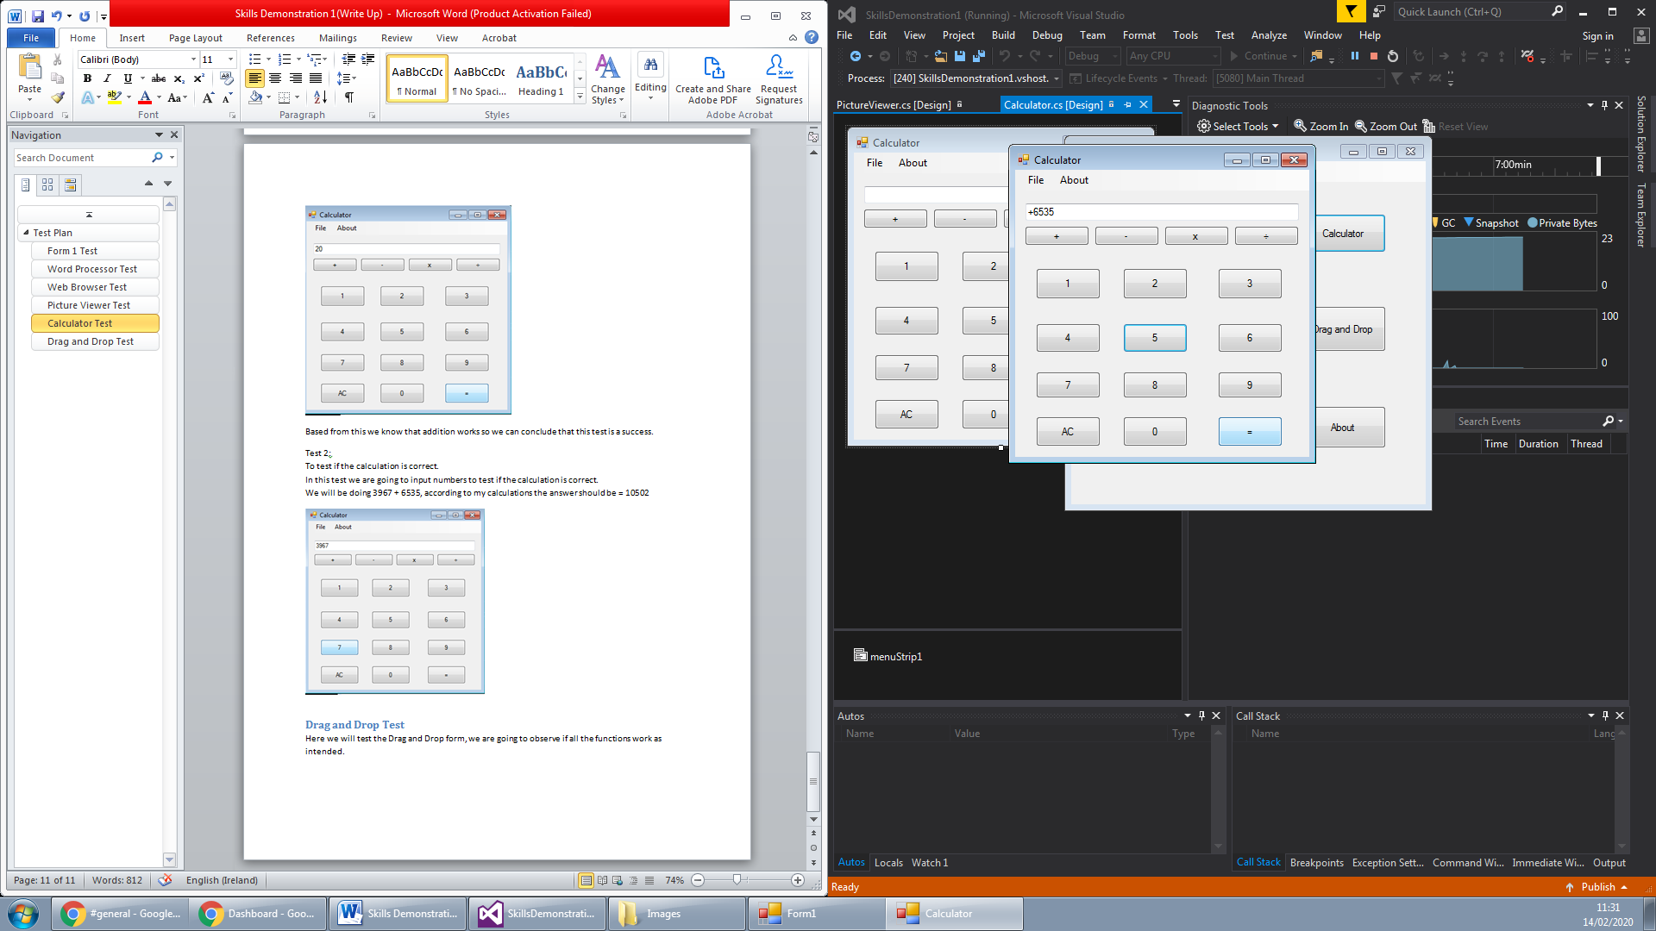

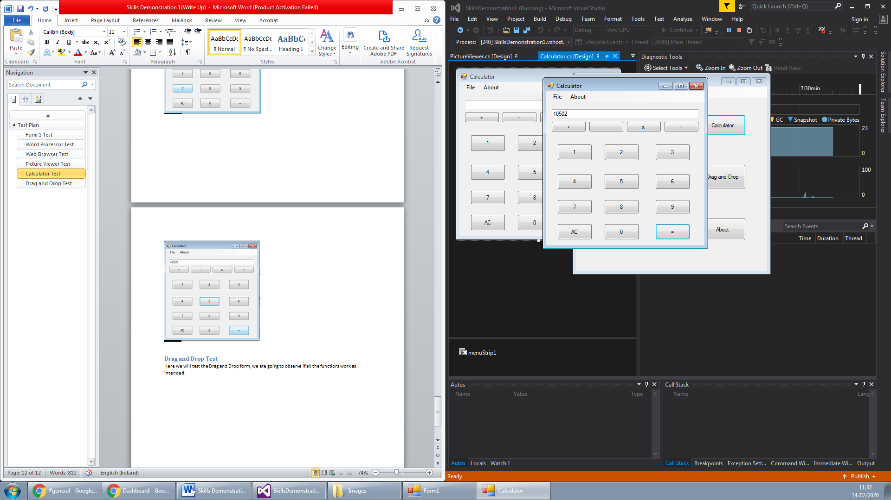  
As the calculation got the same answer as me then I can consider that this test is a success.

## Drag and Drop Test

Here we will test the Drag and Drop form, we are going to observe if all the functions work as intended.

Test 1:  
Testing to see if the drag and drop feature works correctly.  
Our first task is to find something that we wish to drag and drop onto the form/textbox.

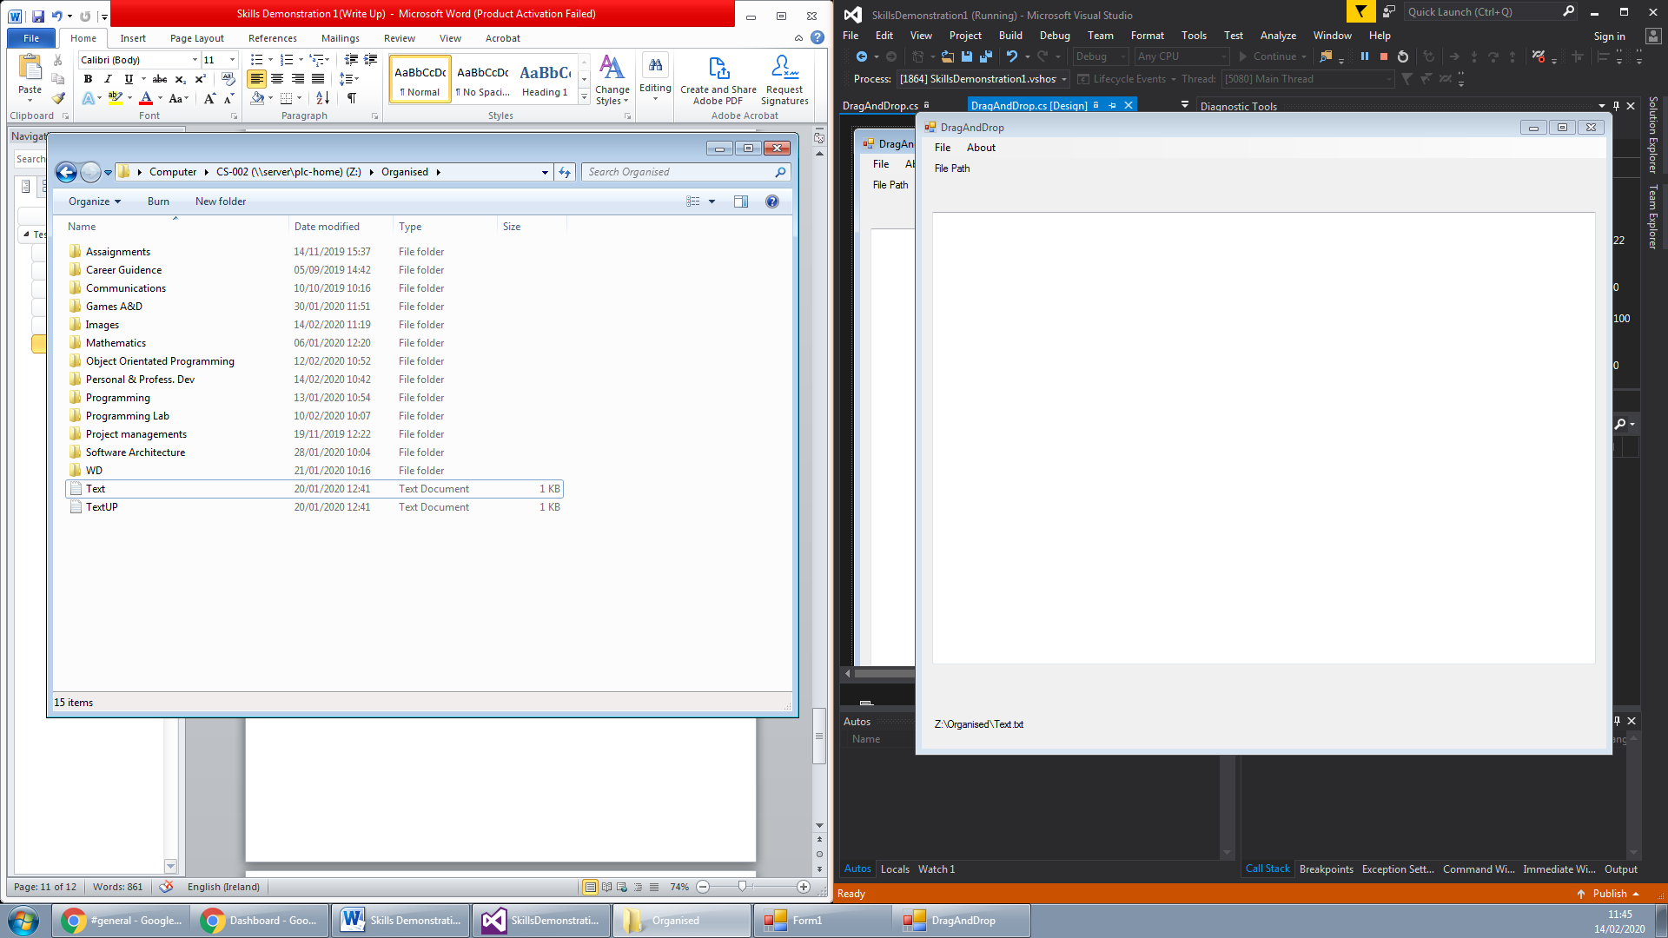  
This is the drag and drop Form. We are going to be dragging a piece of text over to this form.

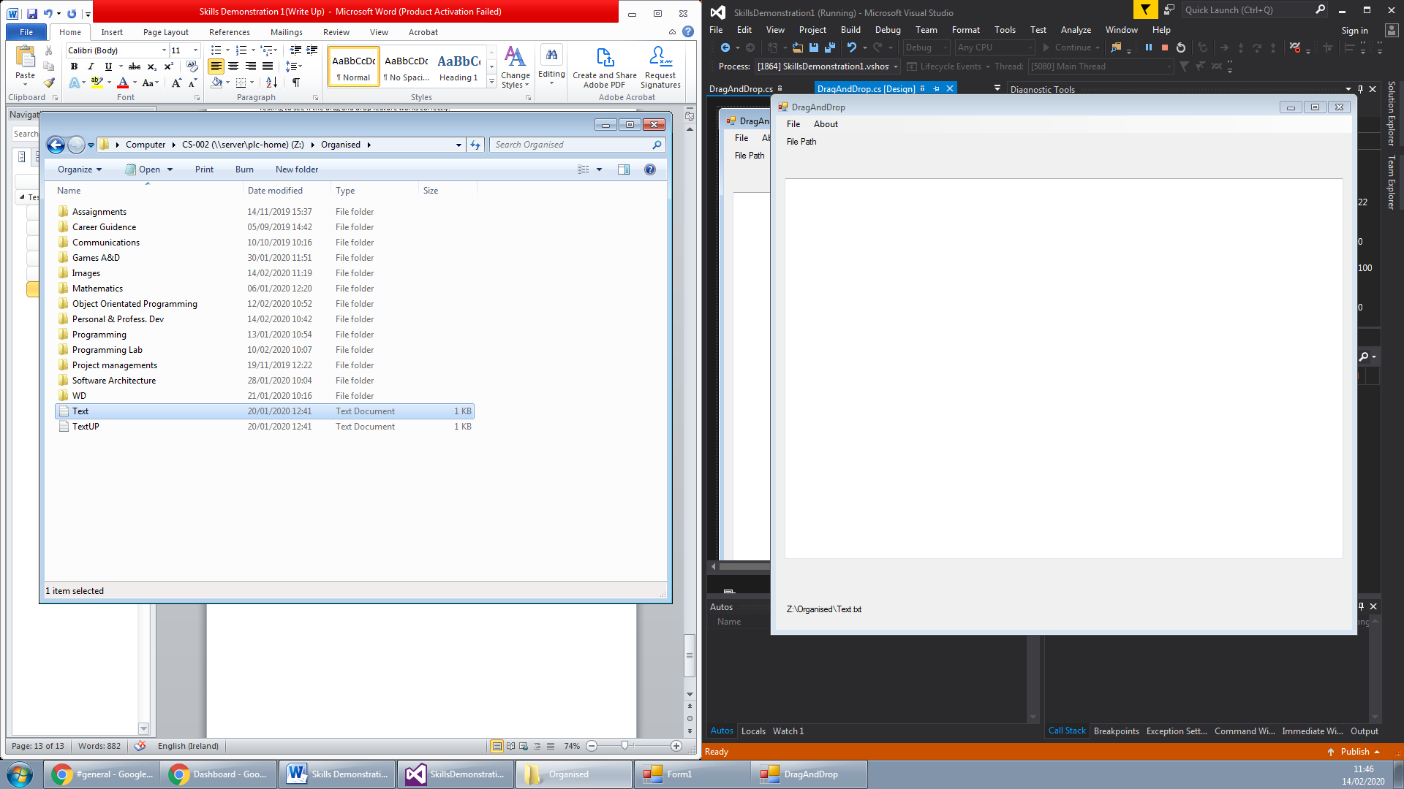  
Now we will see what happens when I drag this text file over to the drag and drop form.

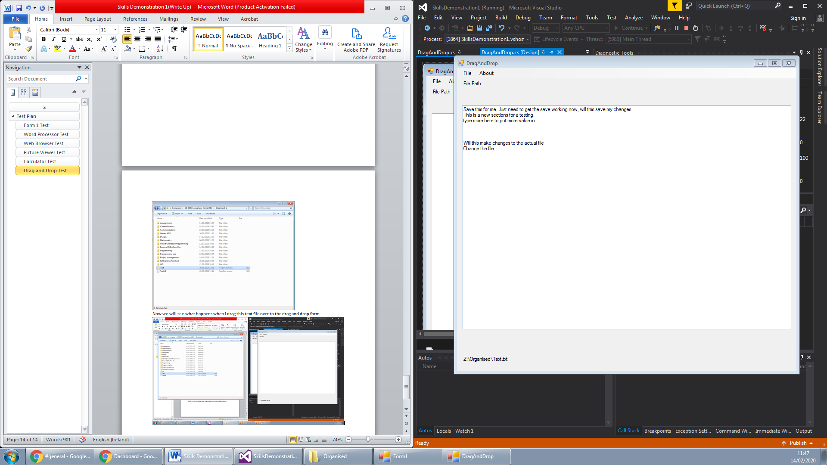  
As expected we got to see that the text from the text file converted from that text file over to the drag and drop form. This would prove that the test was a success.

Test 2:  
Access to the about form from the drag and drop form.  
We will start off with located the access button for the about form on the drag and drop form.

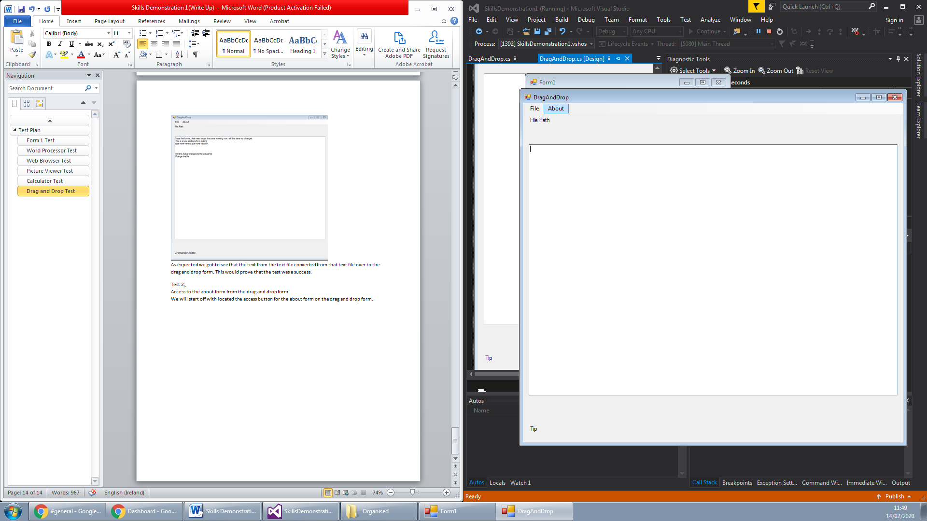  
When we click on the about it should open up the about form to explain about the program.

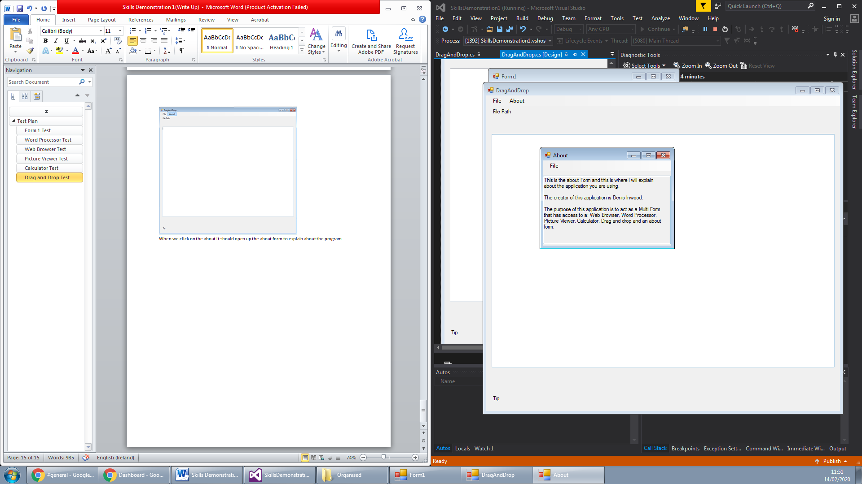  
As expected the about form has opened and this proves that the test was a success.

# End User Guide

Creator of Application: Denis Inwood  
Author of User Guide: Denis Inwood

Forms to View:

Main Form

About Form

Word Processor Form

Calculator Form

Picture Viewer Form

Drag and Drop Form

Web Browser Form

## Main Form

This is the user guide for a simple to use application that contains 5 different programs and an about form to tell you about the application. First I will talk you through about how to use the main Form/Menu. The menu has 6 buttons that are labelled to tell you which application they lead to (Fig 1). You can also open each of the Programs through the file menu strip at the top of the application as well as being able to close the application (Fig 2). Then the last thing is that you can change the background colour of the menu form in the edit menu strip at the top (Fig 3).

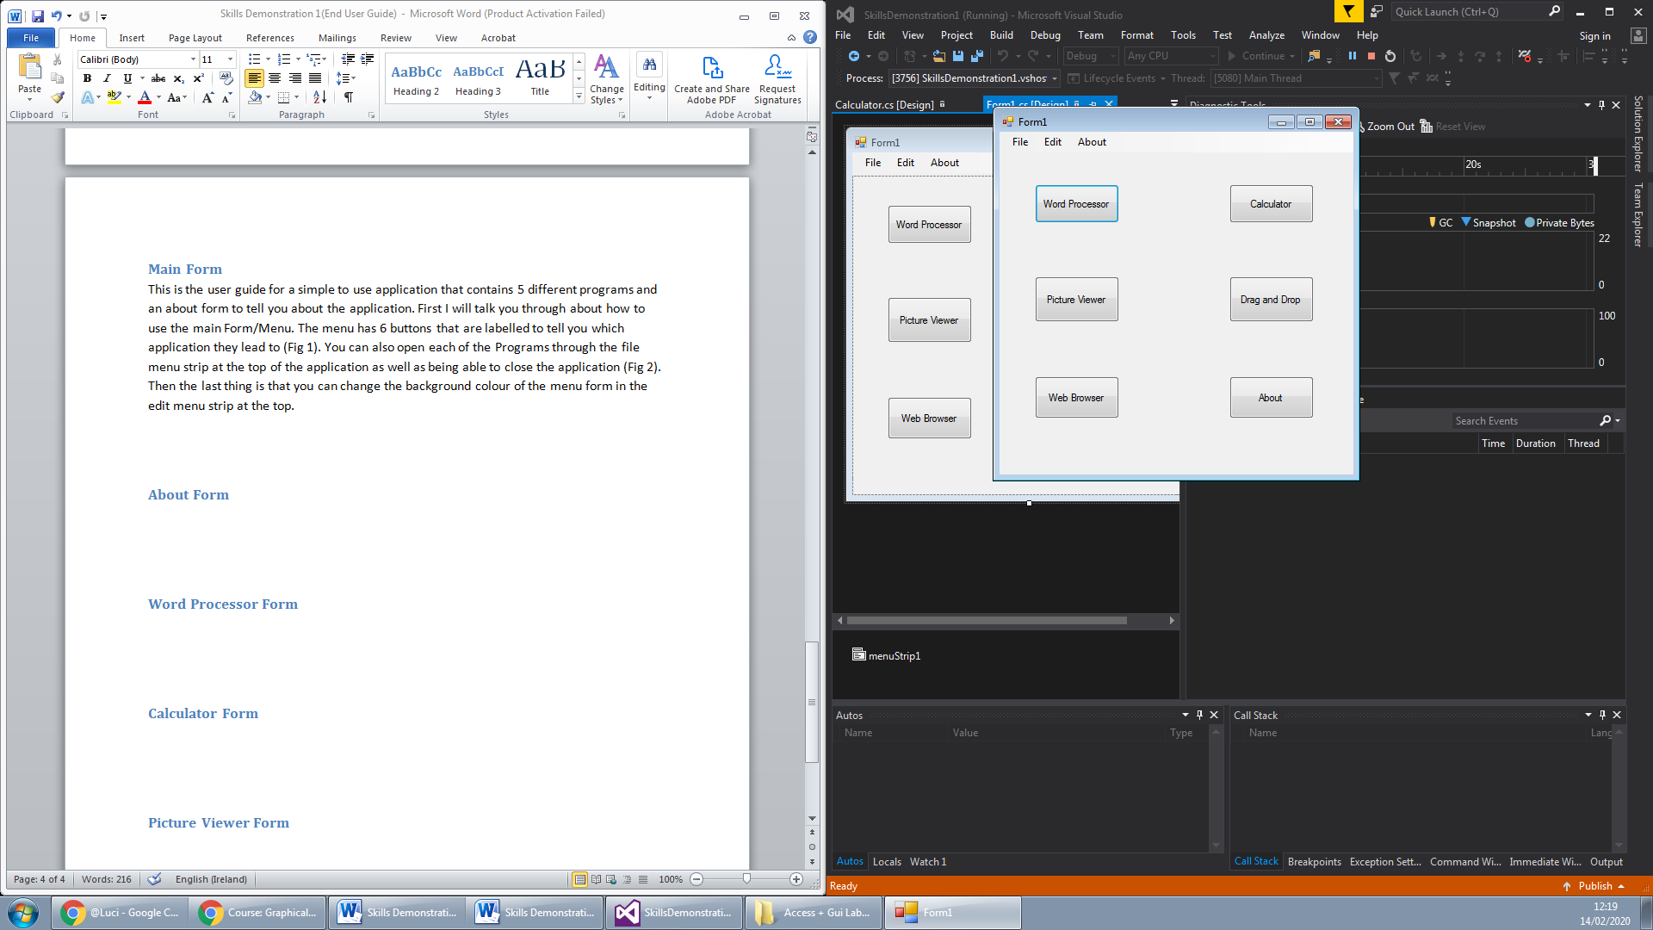 (Fig 1)

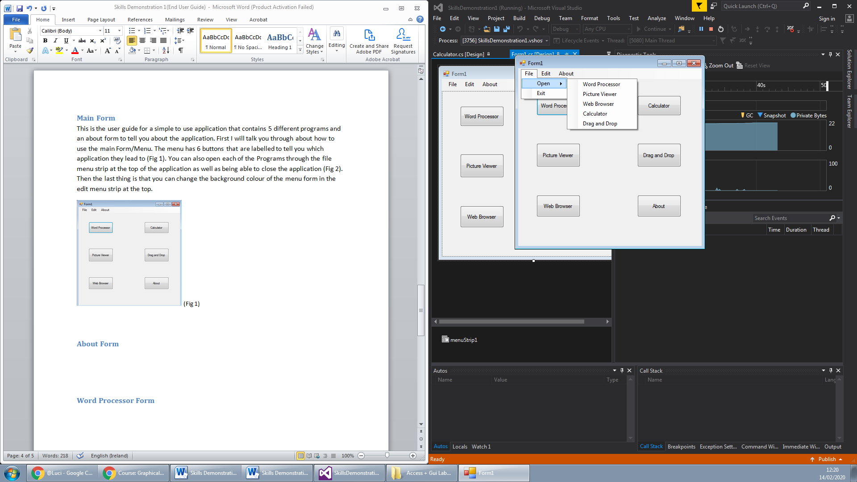 (Fig 2)

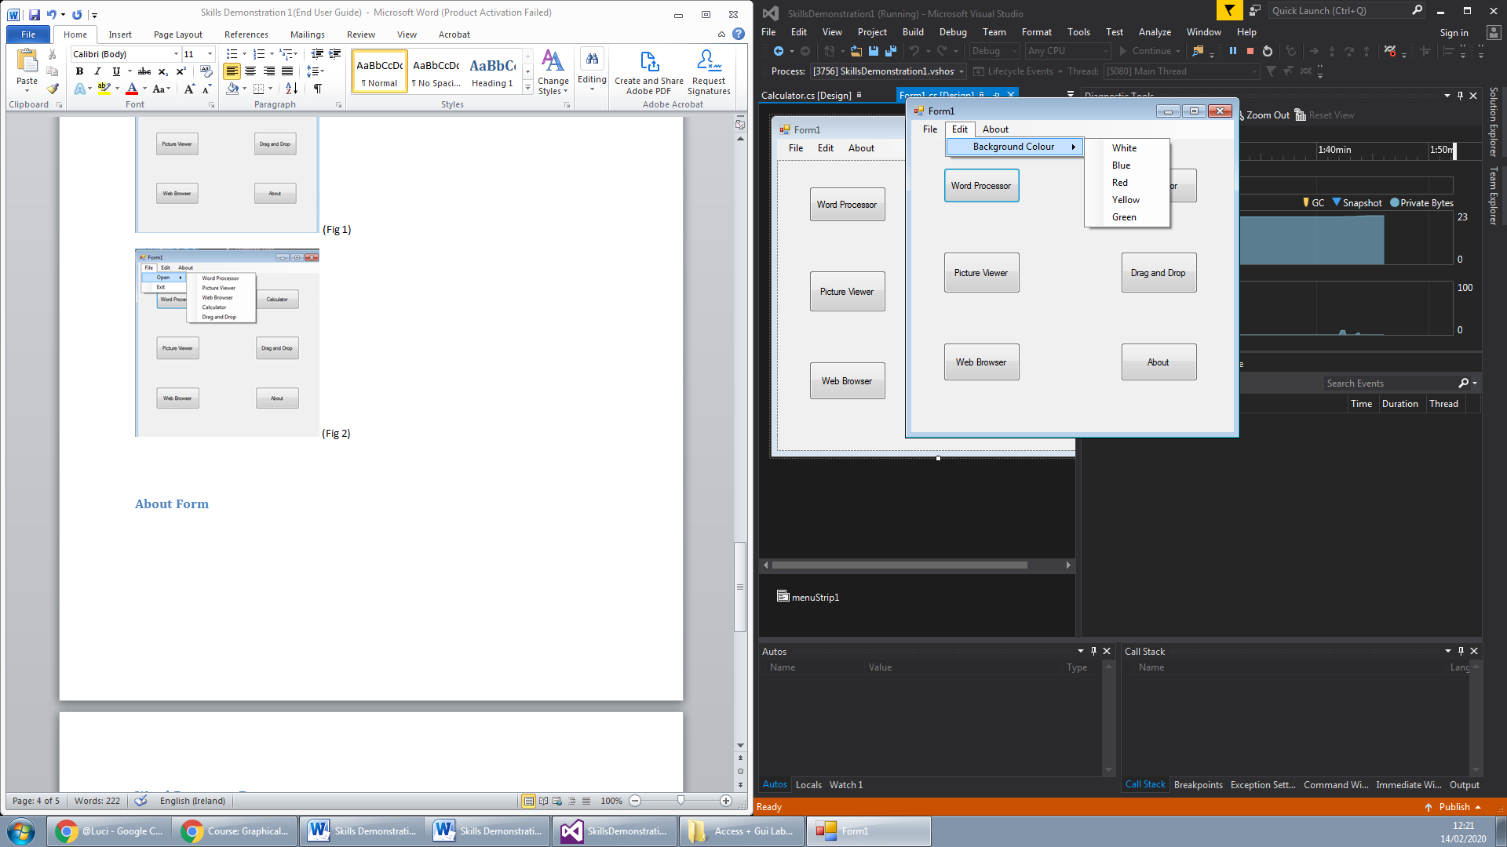 (Fig 3)

## About Form

The about form tells the user about who created the application and explains the purpose of the application (Fig 4).

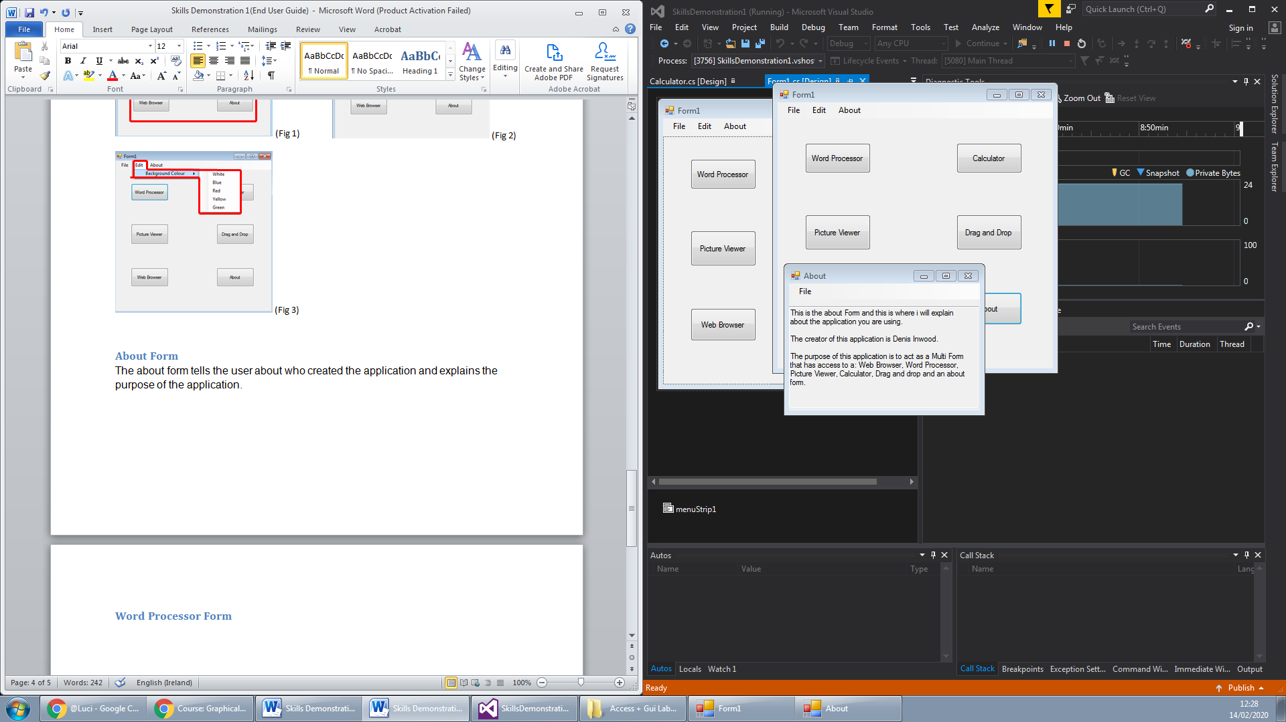 (Fig 4)

## Word Processor Form

The word processor is a text writing program which has some of the same uses as Microsoft word or notepad (Fig 5). You can save files open previous text files and also you can print the text that you have written (Fig 6). The text that you write you can edit that text’s font size and type, font colour and also background colour (Fig 7).

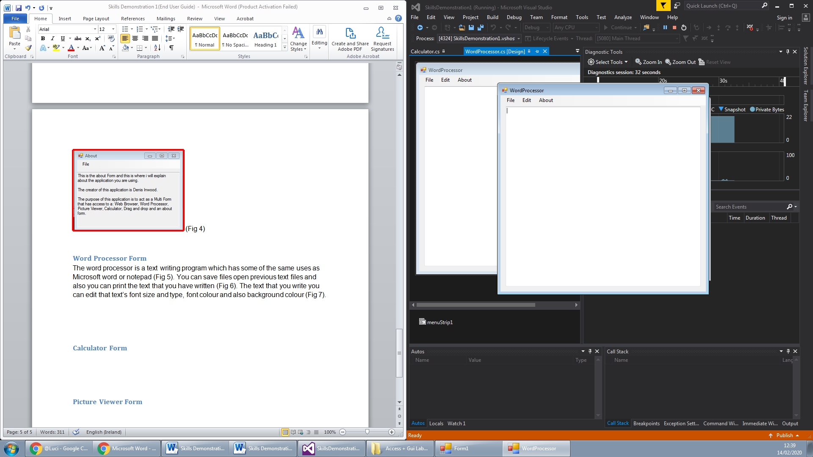 (Fig 5)

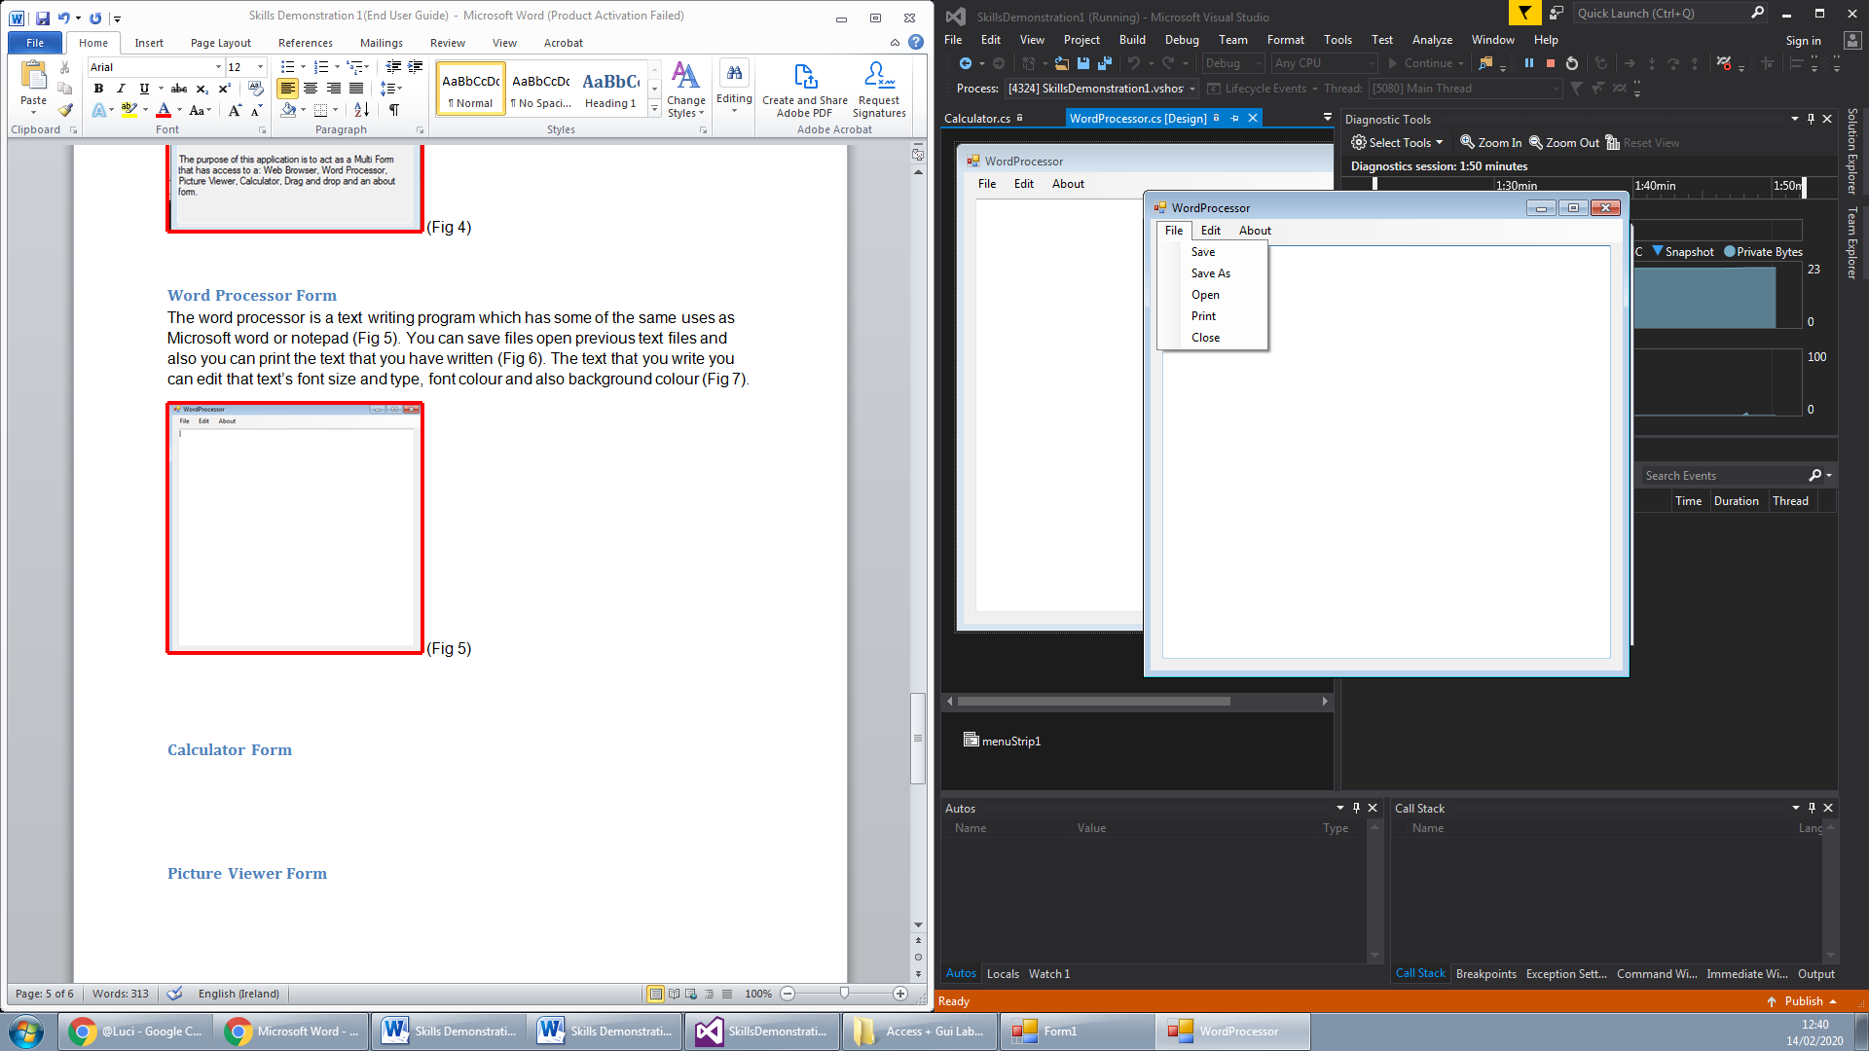 (Fig 6)

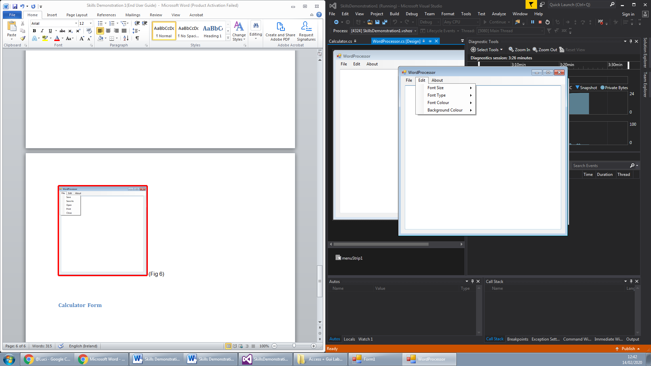 (Fig 7)

## Calculator Form

The calculator program is a base calculator that you can do simple calculations on (Fig 8). You can do addition, subtraction, multiplication and division using the buttons shown (Fig 9). You can also clear the calculator using the AC button (Fig 10).

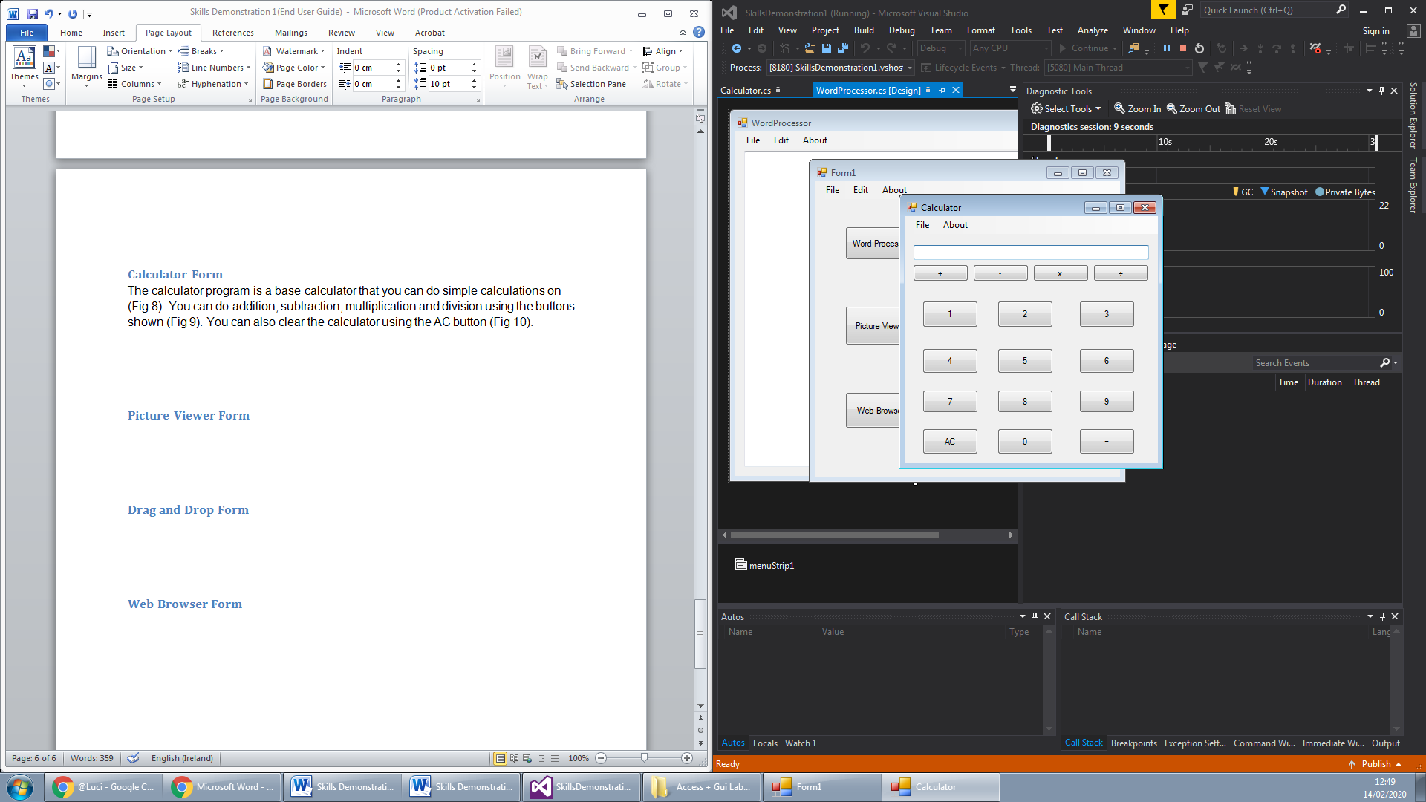 (Fig 8)

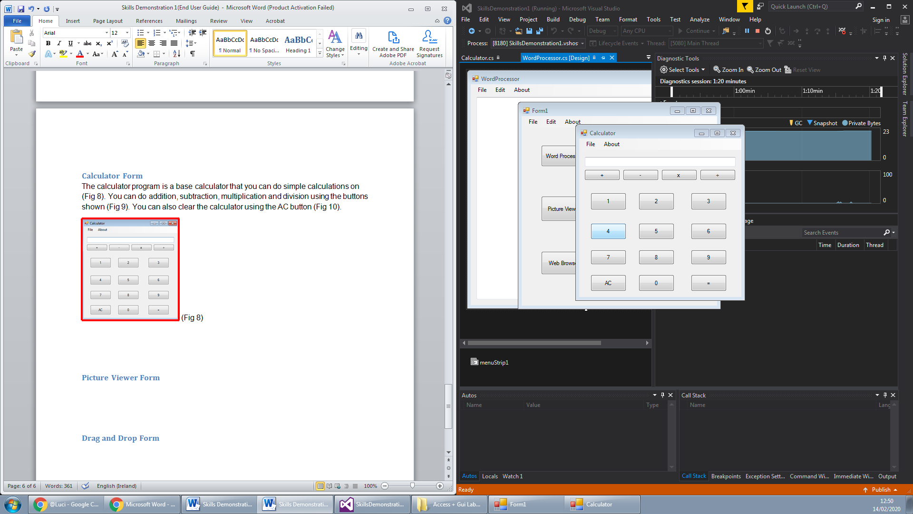 (Fig 9)

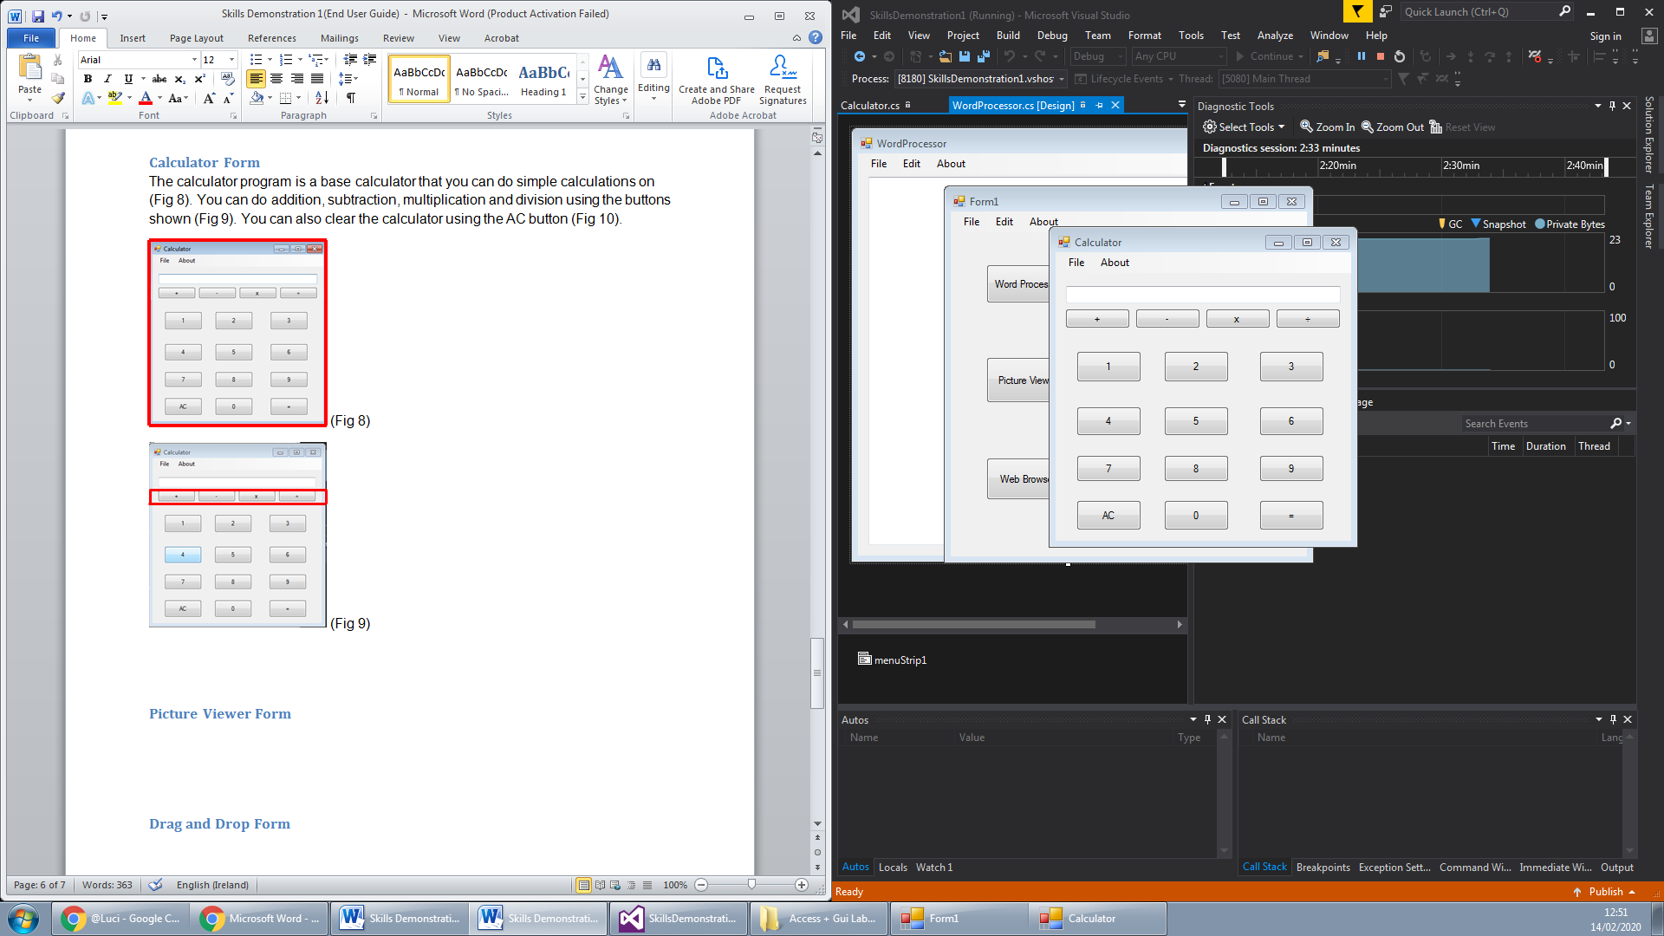 (Fig 10)

## Picture Viewer Form

The Picture Viewer is an application that allows for the user to view pictures that he has saved to his storage (Fig 11). You can open the pictures through the file menu strip at the top (Fig 12). Also if the user wishes to save the image that has been put onto the picture viewer to another location he can save it through the file menu as well (Fig 12).

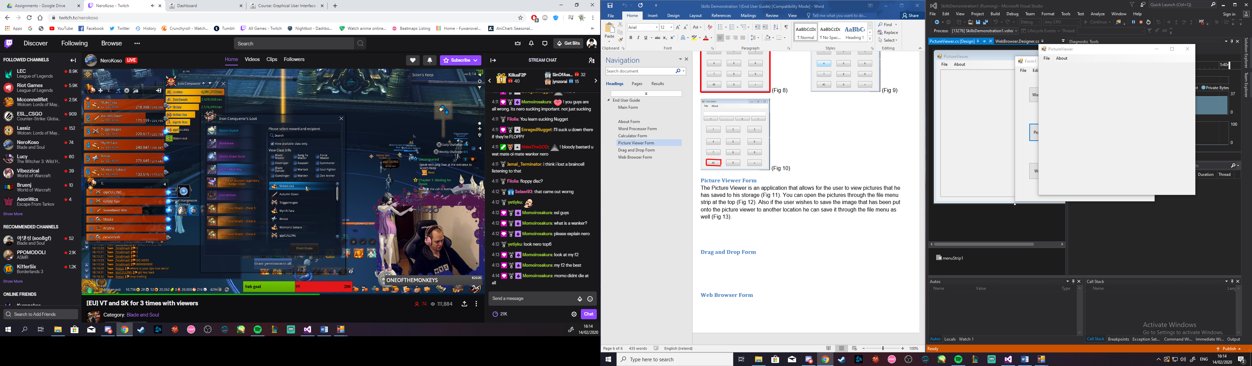 (Fig 11)

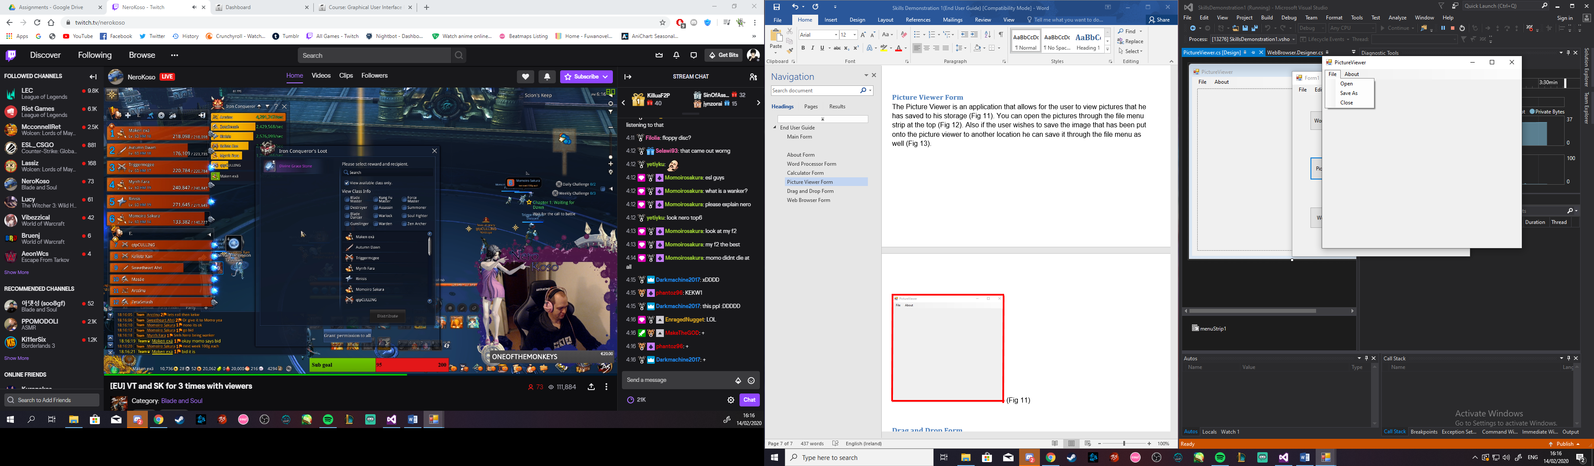 (Fig 12)

## 

## Drag and Drop Form

The Drag and Drop form is a program that allows the user to drag and drop text or images onto the interface and it will appear on the program (Fig 13).

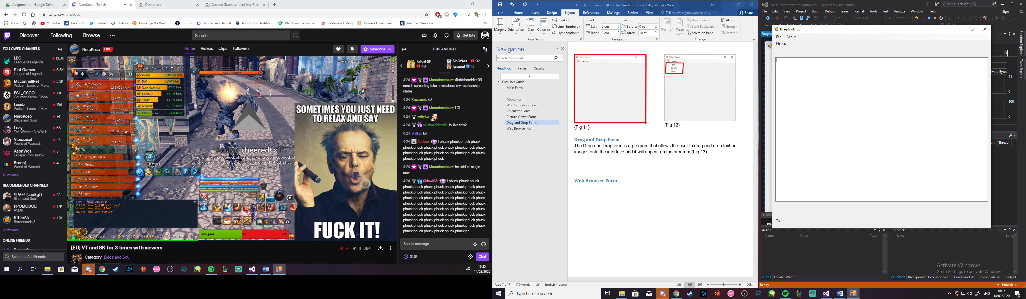 (Fig 13)

## Web Browser Form

The Web browser program is a program that is within the application that works as a search engine for the user (Fig 14). It works just like a web browser and you can search the web and use the usual function of a web browser, H stands for home, Go stands for search, < stands for go back, > stands for go forward, R stands for refresh and X stands for stop (Fig 15).

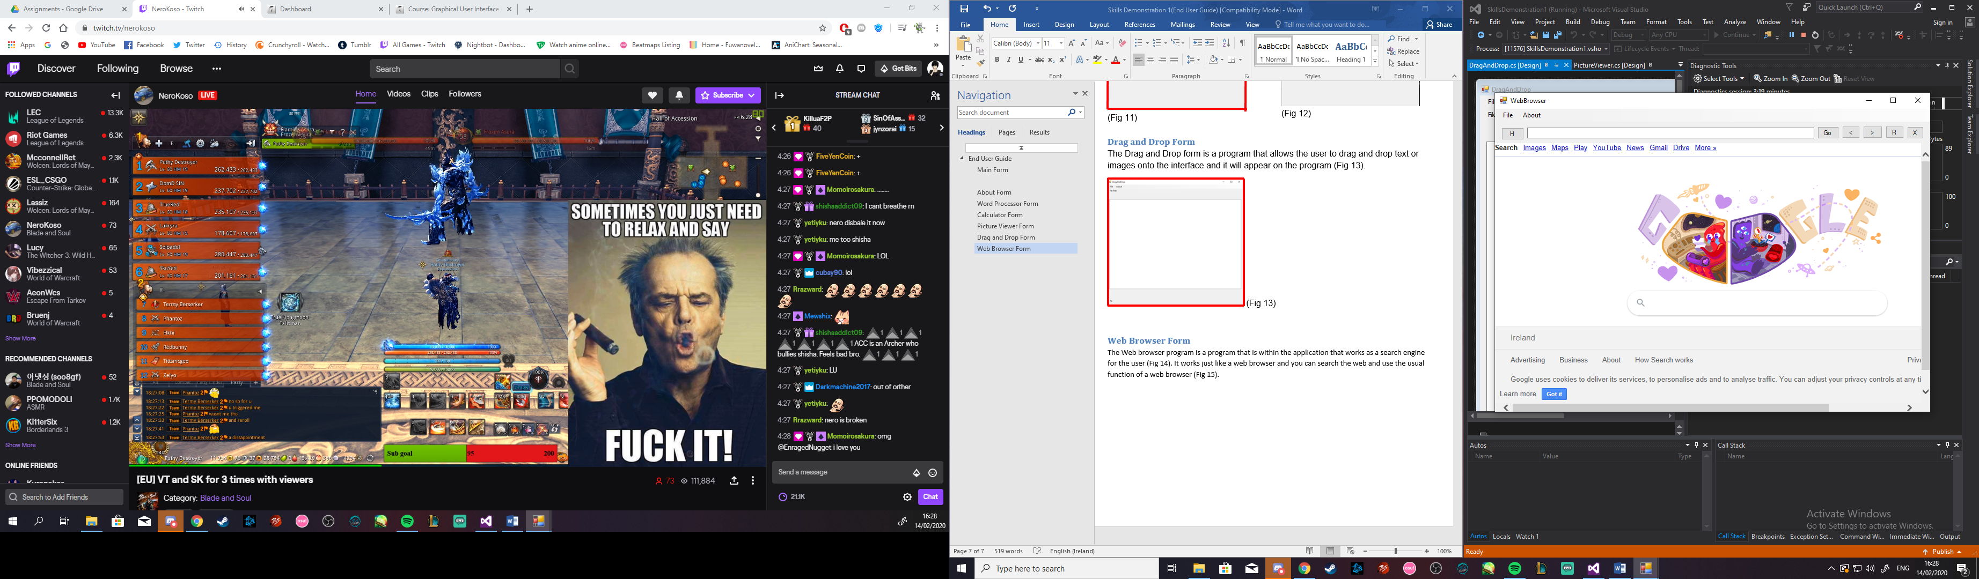 (Fig 14)

 (Fig 15